

**The NorTherN TerriTory real esTaTe local MarkeT reporT sepTeMber QuarTer 2017**

**RELM**

#### **A publication of the Real Estate Institute of Northern Territory Inc.**

**Copyright** ©

in this

ISSUE

FROM THE DESK OF THE CEO **3**

HOUSE SALES **5**

UNIT & TOWNHOUSE SALES **7**

RESIDENTIAL LAND SALES **8**

RURAL HOUSE SALES **13**

RURAL LAND SALES **17**

LITCHFIELD HOUSE SALES **20**

COOMALIE HOUSE SALES **23**

1. HOUSE RENTAL PRICES
2. UNIT RENTAL PRICES
3. RENTAL YIELDS
4. VACANCY RATES

**34** YOUR SUBURB

**40** ANNUAL SALES CHARTS

The RELM is a publication of the Real Estate Institute of Northern Territory Inc. (REINT). All material contained within is copyrighted © to the REINT and may not be copied, used or replicated in any form without prior permission from the REINT.

If you wish to contact the REINT please write to [reception@reint.com.au](mailto:reception@reint.com.au) or call +618 8981 8905.

Strong Market for Investors

FROM THE DESK OF THE CEO

In writing this article I went looking for positive things to say about the Territory housing market. I can tell you that it is good news for investors with the statistics showing that rental yields increased this quarter, up by 0.4 percent to 5 percent on houses (3 bedroom) in Darwin and up



0.6 percent on units (2 bedroom) to 4.7 percent. These remain much higher than most other Australian capital cities.

Core Logic is showing average house yields in Sydney at 2.7 percent, Melbourne at 2.6 percent, Perth at 3.6 percent, Adelaide at 3.9 percent and Brisbane at 4.1 percent. Only Hobart is on par with Darwin with gross rental yields on houses at 5.1 percent.

Alice Springs still holds very strong yields with 5.6 percent on houses and 6.0 percent on units. Interestingly Palmerston also has good rental yields at 4.9 percent on houses and a healthy 5.2 percent on units.

I can also report that anecdotal evidence from our members indicates that 'time on market' is improving substantially over the past few months and the amount of people turning out at opens, auctions and making offers is also increasing.

But that, I'm afraid, is about where most of the good news stops.

While up 6.7 percent against last year, this quarter saw house sales volumes in Greater Darwin drop by 1.9 percent. And with it the median house price for Greater Darwin took a sizeable drop of 8.3 percent, which is 10 percent lower than this time last year.

Palmerston showed some improvement this quarter with house sales up by 2.5 percent or 30.6 percent higher than in 2016, however the median house price in Palmerston remained unchanged this quarter. Alice Springs dropped a little in house sales, down by 1.4 percent but saw a good increase in the median house price which was up 10.8 percent this quarter or 12.5 percent higher than last year.

The unit market followed a similar pattern with sales in Greater Darwin falling a further 5.5 percent this quarter. However, that is 0.6 percent higher than this time last year, so at least that is a tiny bit of good news. Especially when the next measure is the median unit price which fell, for Greater Darwin, by a further 13.8 percent this quarter.

Palmerston saw a sizeable jump in unit sales volumes, up 53.8 percent this quarter, but bear in mind that accounts for just 20 sales in the quarter and is still 52 percent lower than this time last year. The median price of units in Palmerston also fell again this quarter to be 20 percent lower than last year.

I was also looking back at the sales values across the Territory. These are calculated on the total value of all sales (houses and units) across the Territory. In 2015/16 we saw a total of $1.30 billion in sales, which was almost half that of 2014/15 at

$2.24 billion. And that has continued to fall into 2016/17 with only $1.16 billion in sales across the Territory.

So, taking all this into account what does it all mean? The bottom line is that the real estate market is still feeling the effects of a declining population and a market that is wary of making major personal financial investments at the moment, which is not being helped by draconian bank lending policies. As I noted at the start of this article, we are seeing some increased activity in some areas of the market with sellers now accepting where the 'price point' is and buyers looking for bargains, but the overall statistics are not painting a great picture for the remainder of this calender year.

When we look at the falling median prices on both houses and units it does point to some fantastic buying opportunities. We are seeing prices in the Darwin market that we haven't seen for decades - not just years, but decades. If you have been considering getting into your first home, or upgrading to something a little bigger and grander, then this is definitely the time for you to be speaking with an REINT Member Agent.

And just to put the Darwin market into perspective, according to realestate.com.au the median price for a 2 bedroom unit - yes a unit - in Sydney is now $1.32 million with median rent of $900 per week !

**Quentin Kilian**

**REINT Chief Executive Officer**

NortherN territory

**RELM**

report - September Quarter 2017 Page 3



Published by

In association with



**Have you seen The Real Estate Conversation or received our free daily email RECON Daily ?**

**If not, we’d like to invite you to take a look.**

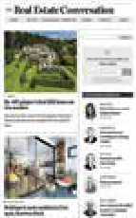

[**www.therealestateconversation.com.au**](http://www.therealestateconversation.com.au/)

**How The Real Estate Conversation can help you:**

* Sign up to RECON Daily, our free daily newsletter
* Feature your properties on RECON Daily to over 70,000 recipients plus a free listing on [www.luxurylist.com.au,](http://www.luxurylist.com.au/) the home of Australia’s premiere luxury real estate
* We have articles and blogs written by experts in their field, and we profile successful and innovative industry members, contributions are welcome
* Market your brand, services, and projects, our international experienced marketing team can help you and your clients achieve desired outcomes

**FOR EQUIRIES EMAIL** [**FARZANA@SCHWARTZWILLIAMS.COM**](mailto:FARZANA@SCHWARTZWILLIAMS.COM) **OR CALL 1300 223 554**

RESIDENTIAL HOUSE SALES

### RESIDENTIAL HOUSE SALES

|  |  |  |  |  |  |  |  |  |  |  |  |
| --- | --- | --- | --- | --- | --- | --- | --- | --- | --- | --- | --- |
| **RESIDENTIAL HOUSE SALES - September Quarter 2017** | | | | | | | | | | | |
| **Recorded Sales** | | | | **Median Price** | | | | **Sales Range** | | | |
| Location | No. Sold | % Change Qtr | % Change Annual | Total Sales Volume | Median Price | % Change Qtr | % Change Annual | Below  $350k | $350k  -  $450k | $450k  -  $600k | Above  $600k |
| Overall Darwin | 207 | -1.9% | 6.7% | $111,035,532 | $495,000 | -8.3% | -10.0% | 16 | 49 | 87 | 55 |
| Darwin Inner | 17 | -22.7% | -19.0% | $13,870,000 | $760,000 | -5.0% | 0.0% | 0 | 1 | 3 | 13 |
| Darwin North East | 1 | -50.0% | -66.7% | $675,000 | $675,000 | -4.9% | -12.3% | 0 | 0 | 0 | 1 |
| Darwin North Coastal | 64 | -7.2% | -1.5% | $39,478,807 | $615,000 | 0.0% | 2.5% | 1 | 8 | 22 | 33 |
| Darwin North | 44 | 12.8% | 2.3% | $20,312,225 | $461,500 | -11.3% | -16.1% | 4 | 14 | 23 | 3 |
| Palmerston | 81 | 2.5% | 30.6% | $36,699,500 | $460,000 | 0.0% | -5.2% | 11 | 26 | 39 | 5 |
| Katherine | 7 | -22.2% | 40.0% | $2,076,000 | $310,000 | -8.8% | -7.5% | 6 | 1 | 0 | 0 |
| Tennant Creek | 3 | -25.0% | -62.5% | $892,500 | $282,500 | 27.0% | 20.2% | 2 | 1 | 0 | 0 |
| Alice Springs | 70 | -1.4% | 34.6% | $34,719,499 | $476,500 | 10.8% | 12.5% | 8 | 18 | 33 | 11 |



**MEDIAN HOUSE SALE PRICE**

$1,000,000

$900,000

$800,000

$700,000

$600,000

$500,000

$400,000

$300,000

$200,000

$100,000

$0

Dec-12 Mar-13 Jun-13 Sep-13 Dec-13 Mar-14 Jun-14 Sep-14 Dec-14 Mar-15 Jun-15 Sep-15 Dec-15 Mar-16 Jun-16 Sep-16 Dec-16 Mar-17 Jun-17 Sep-17

InnerDarwin

TennantCreek

NorthernSuburbs

AliceSprings

Palmerston

DarwinNorthEast

DarwinRural

DarwinNorthCoastal

Katherine

DarwinNorth

NortherN territory

**RELM**

report - September Quarter 2017

Page 5

## 丁o p of the property chain in the

Northern 丁 erritory.

，

##### realestate.com.au is proud to offer agents in the Northe`rn Territory the crocodile's share of views for their listings

Our agent profiles help you stand out.

##### Since lau nching Agent Profiles 12 months ago, agents received: ........

9. 6 milliOn views of agen t pro fi les.'

·..·.·.· ···" ······• --····· •···············...........................................................................................................

##### v艺S, P盓了1 in 6 r e su lt in g in an e n q u ir y !1

···············•··············· ·············· ······· ··············· ·········· ··········· ··········· ········ ·········· ,······· ······ ..······ •······ ···············

. ．

##### '··..... That means more exposure than ever before!

With 3.9 tim es m ore visits to our listings than the industry num ber two ,2 realestate.com.au is helping you get ahead! We remain committed to increasing your exposure in the Northern Territory, and we look forward to working with you in 2016

For more information on the available advantages of your listings, talk to your account manager today.

1 Omnlture lnlernol Data. 0 欢 ember2014 - Oecember及）IS

2. N心沁n Markel lntc时的ce. visilS lo, roolest le.com.•u compared to Domain.com.au,n the Nonhem Terrlt叩

!or O" 卫m bef 2Ol4 . D em决 r 20IS

(a) realest ate.com.au·

RESIDENTIAL UNIT / TOWNHOUSE SALES

**RESIDENTIAL UNIT/TOWNHOUSE SALES**

|  |  |  |  |  |  |  |  |  |  |  |  |
| --- | --- | --- | --- | --- | --- | --- | --- | --- | --- | --- | --- |
| **RESIDENTIAL UNIT / TOWNHOUSE SALES - September Quarter 2017** | | | | | | | | | | | |
| **Recorded Sales** | | | | **Median Price** | | | | **Sales Range** | | | |
| Location | No. Sold | % Change Qtr | % Change Annual | Total Sales Volume | Median Price | % Change Qtr | % Change Annual | Below  $350k | $350k  -  $450k | $450k  -  $600k | Above  $600k |
| Overall Darwin | 171 | -5.5% | 0.6% | $72,425,300 | $405,000 | -13.8% | -12.0% | 58 | 39 | 59 | 15 |
| Darwin Inner | 109 | -13.5% | 45.3% | $49,889,500 | $465,833 | -11.7% | -12.9% | 23 | 26 | 47 | 13 |
| Darwin North East | 7 | 40.0% | -30.0% | $3,640,000 | $550,000 | 45.3% | 0.0% | 1 | 0 | 6 | 0 |
| Darwin North Coastal | 26 | -13.3% | -35.0% | $9,473,000 | $310,000 | -20.5% | -32.6% | 15 | 4 | 5 | 2 |
| Darwin North | 9 | 28.6% | 200.0% | $2,837,500 | $315,000 | -6.0% | -18.2% | 8 | 1 | 0 | 0 |
| Palmerston | 20 | 53.8% | -52.4% | $6,585,300 | $325,000 | -5.8% | -26.1% | 11 | 8 | 1 | 0 |
| Katherine | 1 | -50.0% | -50.0% | $320,000 | $320,000 | 18.5% | -54.3% | 1 | 0 | 0 | 0 |
| Tennant Creek | 0 |  |  | $- |  |  |  | 0 | 0 | 0 | 0 |
| Alice Springs | 33 | 0.0% | -31.3% | $11,912,053 | $320,000 | 10.9% | 22.8% | 19 | 5 | 7 | 2 |



**MEDIAN UNIT SALE PRICE**

$800,000

$700,000

$600,000

$500,000

$400,000

$300,000

$200,000

$100,000

$0

Dec-12 Mar-13 Jun-13 Sep-13 Dec-13 Mar-14 Jun-14 Sep-14 Dec-14 Mar-15 Jun-15 Sep-15 Dec-15 Mar-16 Jun-16 Sep-16 Dec-16 Mar-17 Jun-17 Sep-17

InnerDarwin

AliceSprings

Palmerston

DarwinNorthEast

Katherine

DarwinNorthCoastal

TennantCreek

DarwinNorth

NortherN territory

**RELM**

report - September Quarter 2017

Page 7

RESIDENTIAL LAND SALES

### RESIDENTIAL LAND SALES

|  |  |  |  |  |  |  |  |  |  |  |  |
| --- | --- | --- | --- | --- | --- | --- | --- | --- | --- | --- | --- |
| **RESIDENTIAL LAND SALES - September Quarter 2017 - UNDER 600 SQM** | | | | | | | | | | | |
| **Recorded Sales** | | | | **Median Price** | | | | **Sales Range** | | | |
| Location | No. Sold | % Change Qtr | % Change Annual | Total Sales Volume | Median Price | % Change Qtr | % Change Annual | Below  $350k | $350k  -  $450k | $450k  -  $600k | Above  $600k |
| Overall Darwin | 42 | -45.5% | -70.0% | $8,243,500 | $197,500 | 19.7% | 20.4% | 41 | 1 | 0 | 0 |
| Darwin Inner | 1 |  |  | $410,000 | $410,000 |  |  | 0 | 1 | 0 | 0 |
| Darwin North East | 0 |  |  | $- |  |  |  | 0 | 0 | 0 | 0 |
| Darwin North Coastal | 0 |  |  | $- |  |  |  | 0 | 0 | 0 | 0 |
| Darwin North | 0 |  |  | $- |  |  |  | 0 | 0 | 0 | 0 |
| Palmerston | 41 | -46.8% | -70.5% | $7,833,500 | $197,000 | 19.4% | 20.9% | 41 | 0 | 0 | 0 |
| Katherine | 4 | 300.0% |  | $424,400 | $111,600 | 55.4% |  | 4 | 0 | 0 | 0 |
| Tennant Creek | 0 |  |  | $- |  |  |  | 0 | 0 | 0 | 0 |
| Alice Springs | 0 |  |  | $- |  |  |  | 0 | 0 | 0 | 0 |

|  |  |  |  |  |  |  |  |  |  |  |  |
| --- | --- | --- | --- | --- | --- | --- | --- | --- | --- | --- | --- |
| **RESIDENTIAL LAND SALES - September Quarter 2017 - 601 TO 800 SQM** | | | | | | | | | | | |
| **Recorded Sales** | | | | **Median Price** | | | | **Sales Range** | | | |
| Location | No. Sold | % Change Qtr | % Change Annual | Total Sales Volume | Median Price | % Change Qtr | % Change Annual | Below  $350k | $350k  -  $450k | $450k  -  $600k | Above  $600k |
| Overall Darwin | 15 | 150.0% | -21.1% | $3,783,500 | $236,000 | -22.0% | 0.4% | 14 | 1 | 0 | 0 |
| Darwin Inner | 0 |  |  | $- |  |  |  | 0 | 0 | 0 | 0 |
| Darwin North East | 0 |  |  | $- |  |  |  | 0 | 0 | 0 | 0 |
| Darwin North Coastal | 1 | 0.0% | -85.7% | $412,500 | $412,500 | 19.6% | 17.9% | 0 | 1 | 0 | 0 |
| Darwin North | 0 |  |  | $- |  |  |  | 0 | 0 | 0 | 0 |
| Palmerston | 14 | 180.0% | 16.7% | $3,371,000 | $235,500 | -9.4% | 2.4% | 14 | 0 | 0 | 0 |
| Katherine | 0 |  |  | $- |  |  |  | 0 | 0 | 0 | 0 |
| Tennant Creek | 0 |  |  | $- |  |  |  | 0 | 0 | 0 | 0 |
| Alice Springs | 0 |  |  | $- |  |  |  | 0 | 0 | 0 | 0 |

Page 8 NortherN territory report - September Quarter 2017

**RELM**

RESIDENTIAL LAND SALES

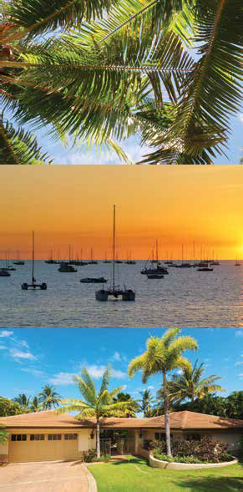

Darwin’s #1 Finance and

Insurance Group

Purchasing a Home?

Looking for a more competitive Loan?

After Insurance Options for Home or Business?

Contact Able Finance on:

Phone: 1300 LENDER

Check us out on Facebook – search “Able Finance”

Watch our weekly Video Blog – search Able Finance on Youtube for free Tips, Tricks and Tutorials

***Crowley Wealth Pty Ltd T/As Able Insurance Services NT is a Corporate Authorised Representative of Westcourt General Insurance Brokers | CAR No: 335083 | Shane Crowley AR No: 318952***

### RESIDENTIAL LAND SALES

|  |  |  |  |  |  |  |  |  |  |  |  |
| --- | --- | --- | --- | --- | --- | --- | --- | --- | --- | --- | --- |
| **RESIDENTIAL LAND SALES - September Quarter 2017 - 801 TO 2000 SQM** | | | | | | | | | | | |
| **Recorded Sales** | | | | **Median Price** | | | | **Sales Range** | | | |
| Location | No. Sold | % Change Qtr | % Change Annual | Total Sales Volume | Median Price | % Change Qtr | % Change Annual | Below  $350k | $350k  -  $450k | $450k  -  $600k | Above  $600k |
| Overall Darwin | 5 | -28.6% | -37.5% | $2,520,000 | $350,000 | 20.7% | 21.7% | 3 | 0 | 0 | 2 |
| Darwin Inner | 2 |  |  | $1,655,000 | $827,500 |  |  | 0 | 0 | 0 | 2 |
| Darwin North East | 0 |  |  | $- |  |  |  | 0 | 0 | 0 | 0 |
| Darwin North Coastal | 0 |  |  | $- |  |  |  | 0 | 0 | 0 | 0 |
| Darwin North | 0 |  |  | $- |  |  |  | 0 | 0 | 0 | 0 |
| Palmerston | 3 | -57.1% | -57.1% | $865,000 | $260,000 | -10.3% | -5.5% | 3 | 0 | 0 | 0 |
| Katherine | 0 |  |  | $- |  |  |  | 0 | 0 | 0 | 0 |
| Tennant Creek | 3 |  | 200.0% | $135,000 | $50,000 |  | -14.5% | 3 | 0 | 0 | 0 |
| Alice Springs | 4 |  |  | $1,037,500 | $200,000 |  |  | 3 | 0 | 1 | 0 |

What is easyBondpay?



ea syBondpay™

mok．心，ntin9 · · s ior fo« you

、

'

P ROUD SPONSOR OF

R

REAl 氐 A

EIN

在 iNSTTfUTE

Of NORTHERN TERRITORY

T

．

EasyBondpay is an exciting new bond payment facility for tenants and property managers looking to streamline the bond payment process.

Make bond payments EASY with easyBondpay.

000000

EASY 1 MINUTE INTERNET APPLICATION NO MINIMUM OR MAXIMUM BOND VALUE INSTANT APPROVAL

NO SUPPORTING DOCUMENTS REQUIRED SAME DAY, FULL BOND PAYMENT ADDITIONAL REVENUE OPPORTUNITY

EasyBondpay is a proud sponsor of The Real Estate Instit u te of Northern Territory

www.easybondpay.com.au or call us on 1300 022 663

**WELCOME TO BMW ADVANTAGE.**



**YOUR EXCLUSIVE EMPLOYEE BENEFITS FOR A MORE REWARDING JOURNEY.**

As a member of Real Estate Institute of Northern Territory (REINT), BMW Group Australia and Darwin BMW are pleased to extend you the many rewards of BMW Advantage, entitling you to exclusive benefits with the purchase of a new BMW.

All individual members of REINT are eligible to receive Gold member benefits, which represent significant value and are provided to you as part of REINT membership. Eligible vehicles may be purchased via your fleet or novated provider, or privately.

**BMW ADVANTAGE – GOLD MEMBER BENEFITS INCLUDE:**

* Complimentary BMW Service Inclusive for 4 years / 60,000km
* Corporate pricing
* Reduced dealer delivery charges
* Reduced rate on a BMW Driving Experience course

Your spouse is also entitled to enjoy all the benefits of BMW Advantage when they purchase a new BMW, making it even more appealing.

All new BMW models include a 3 Year/Unlimited Kilometres Warranty and 3 Years Roadside Assistance as standard. In addition, if 50 BMW models or more are registered during the calendar year by your fellow members, all vehicles will be upgraded to BMW Advantage Platinum status and will enjoy complimentary BMW Service Inclusive for 5 years / 80,000km.

To find out more about the many rewards of BMW Advantage, book a test-drive or order a brochure, visit bmw.com.au/advantage and enter your member number and password.

To start your rewarding journey with BMW Advantage, remember to inform Darwin BMW that you are a BMW Advantage member from REINT when enquiring about your new vehicle.

**DISCOVER YOUR ULTIMATE REWARD WITH BMW ADVANTAGE.**

**Darwin BMW** 544 Stuart Highway, Winnellie. (08) 8928 5500. [www.darwinmotorgroup.com.au](http://www.darwinmotorgroup.com.au/) LMVD 403

*Benefits apply to the purchase of a new BMW vehicle and only to the vehicle purchased. Subject to eligibility. Terms, conditions, exclusions and other limitations apply. Consult Darwin BMW for further details or go to bmw.com.au/advantage.

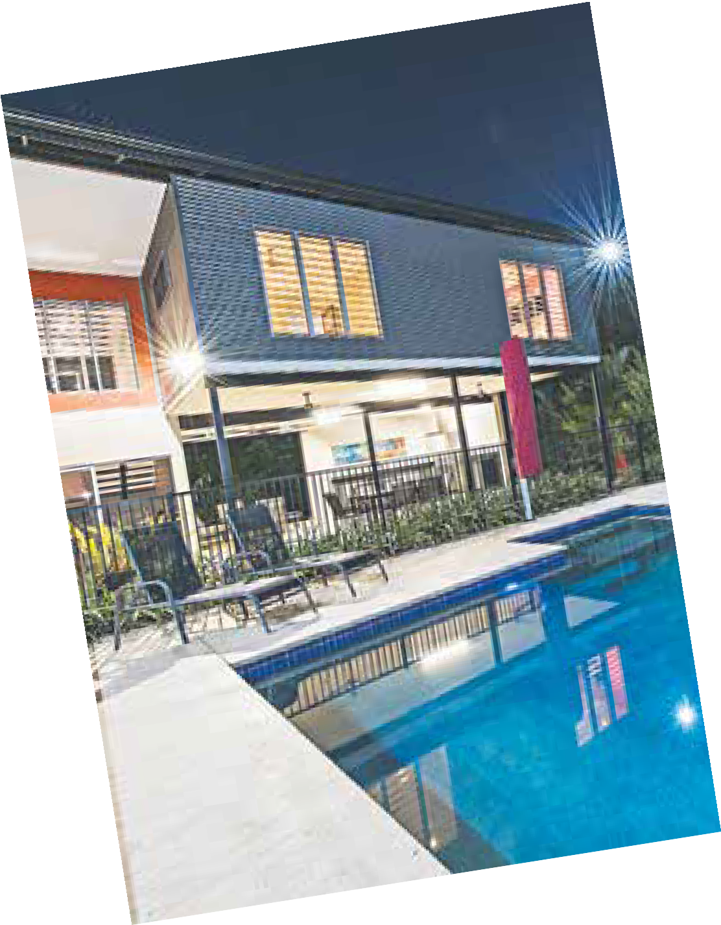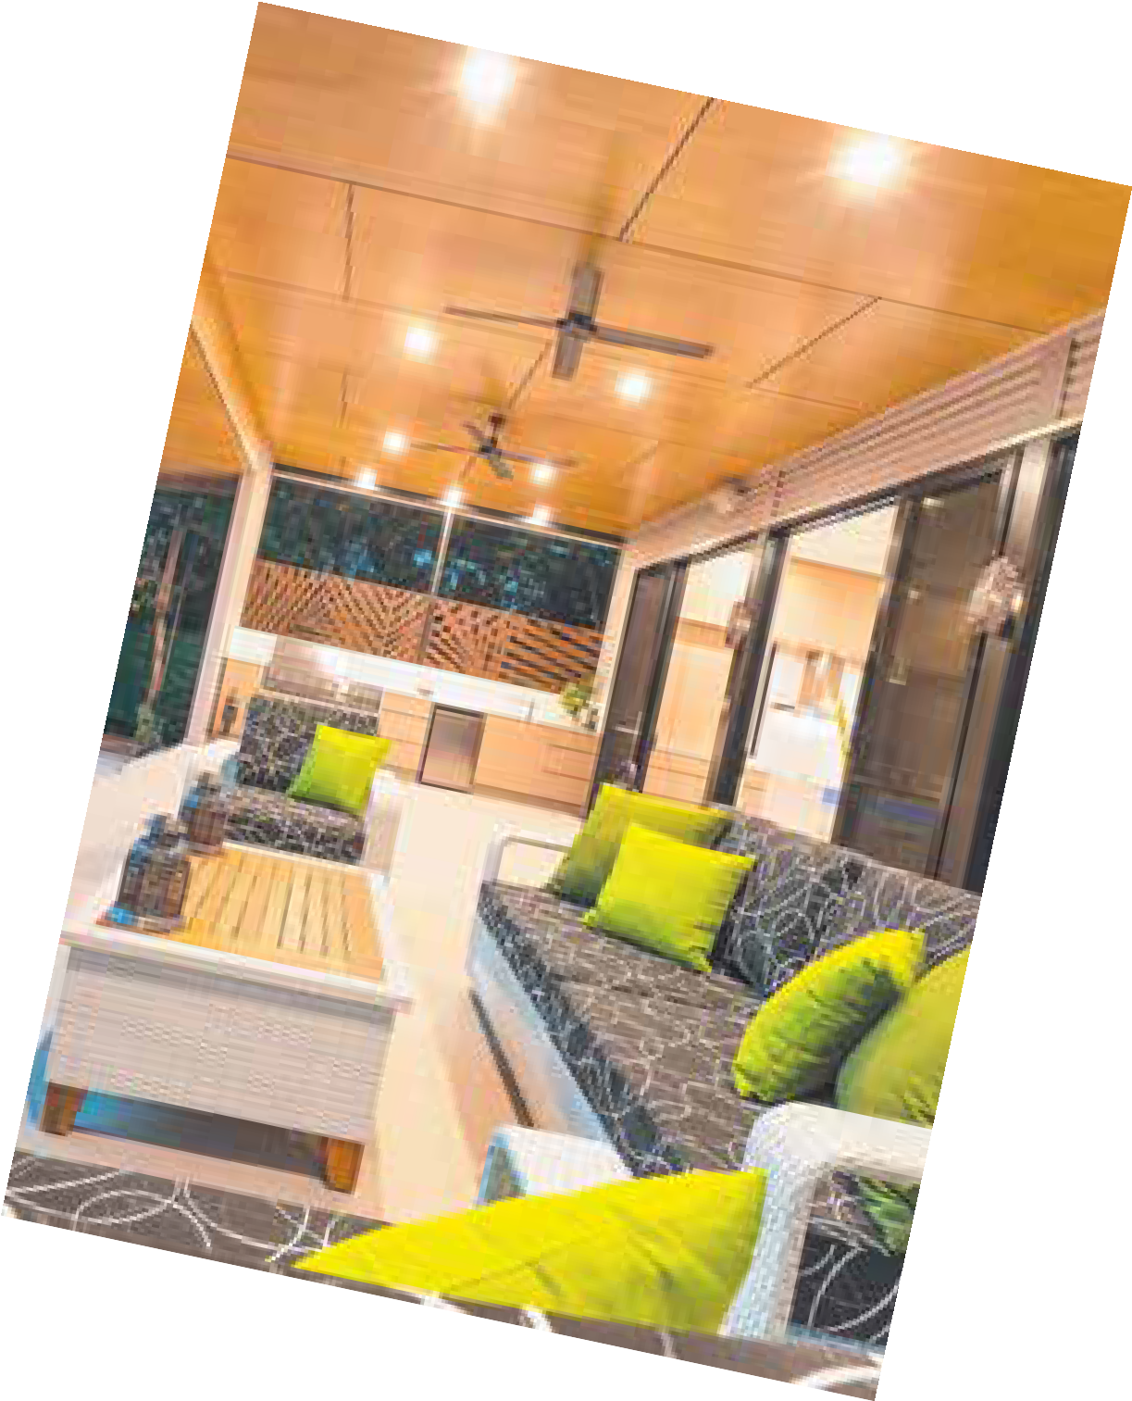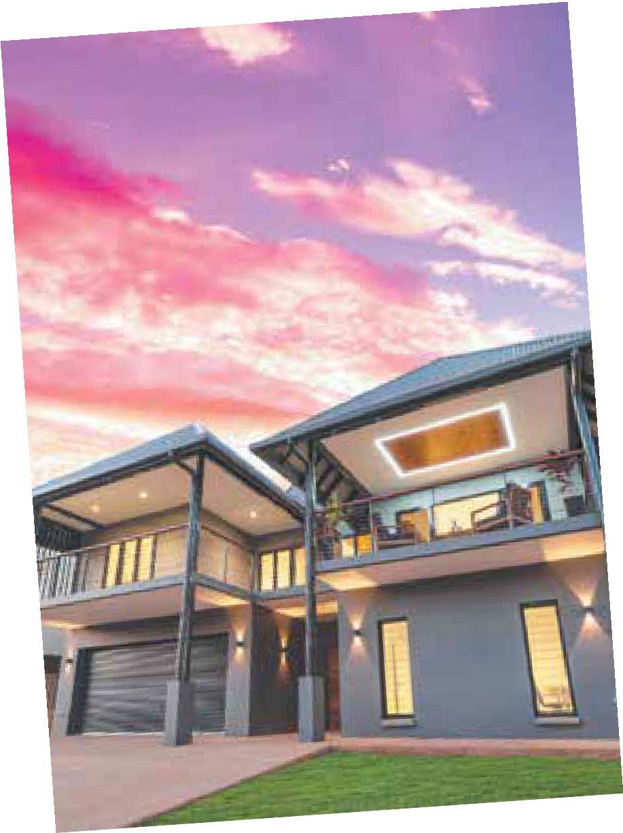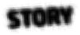

**TO 48,000^ READERS**

^Source: emmaTM conducted by IpsosMediaCT, 12 months ending August 2017, NT People 14+

RURAL HOUSE SALES

### RURAL HOUSE SALES

|  |  |  |  |  |  |  |  |  |  |  |  |
| --- | --- | --- | --- | --- | --- | --- | --- | --- | --- | --- | --- |
| **RURAL HOUSE SALES - September Quarter 2017 - UP TO 2ha** | | | | | | | | | | | |
| **Recorded Sales** | | | | **Median Price** | | | **Sales Range** | | | | |
| Location | No. Sold | % Change Qtr | % Change Annual | Total Sales Volume | Median Price | % Change Qtr | % Change Annual | Below  $350k | $350k  -  $450k | $450k  -  $600k | Above  $600k |
| Alice Springs | 4 | 33.3% | 0.0% | $3,335,000 | $812,500 | 8.3% | 10.2% | 0 | 0 | 0 | 4 |
| Tennant Creek | 0 |  |  | $- |  |  |  | 0 | 0 | 0 | 0 |
| Belyuen | 0 |  |  | $- |  |  |  | 0 | 0 | 0 | 0 |
| Central Desert | 0 |  |  | $- |  |  |  | 0 | 0 | 0 | 0 |
| Coomalie | 1 |  | 0.0% | $250,000 | $250,000 |  | -42.5% | 1 | 0 | 0 | 0 |
| Darwin East | 0 |  |  | $- |  |  |  | 0 | 0 | 0 | 0 |
| Darwin Inner | 0 |  |  | $- |  |  |  | 0 | 0 | 0 | 0 |
| Darwin North | 0 |  |  | $- |  |  |  | 0 | 0 | 0 | 0 |
| Darwin North Coastal | 2 | 100.0% | 100.0% | $2,122,000 | $1,061,000 | 72.5% | 1.0% | 0 | 0 | 0 | 2 |
| Darwin North East | 0 |  |  | $- |  |  |  | 0 | 0 | 0 | 0 |
| Dundee | 3 |  | 0.0% | $1,093,000 | $295,000 |  | -1.7% | 2 | 0 | 1 | 0 |
| East Arhnem | 0 |  |  | $- |  |  |  | 0 | 0 | 0 | 0 |
| East Arm | 0 |  |  | $- |  |  |  | 0 | 0 | 0 | 0 |
| Katherine | 1 |  |  | $650,000 | $650,000 |  |  | 0 | 0 | 0 | 1 |
| Litchfield | 24 | -7.7% | 0.0% | $16,565,000 | $653,500 | 8.0% | 15.2% | 5 | 1 | 5 | 13 |
| MacDonnell | 0 |  |  | $- |  |  |  | 0 | 0 | 0 | 0 |
| Margaret River | 0 |  |  | $- |  |  |  | 0 | 0 | 0 | 0 |
| Marrakai | 0 |  |  | $- |  |  |  | 0 | 0 | 0 | 0 |
| Palmerston | 0 |  |  | $- |  |  |  | 0 | 0 | 0 | 0 |
| Roper Gulf | 0 |  |  | $- |  |  |  | 0 | 0 | 0 | 0 |
| Tiwi Islands | 0 |  |  | $- |  |  |  | 0 | 0 | 0 | 0 |
| Victoria Daly | 0 |  |  | $- |  |  |  | 0 | 0 | 0 | 0 |
| Wagait | 2 |  | 100.0% | $1,460,000 | $730,000 |  | 66.7% | 0 | 0 | 1 | 1 |
| West Arhnem | 0 |  |  | $- |  |  |  | 0 | 0 | 0 | 0 |

NortherN territory

**RELM**

report - September Quarter 2017

Page 13

RURAL HOUSE SALES

### RURAL HOUSE SALES

|  |  |  |  |  |  |  |  |  |  |  |  |
| --- | --- | --- | --- | --- | --- | --- | --- | --- | --- | --- | --- |
| **RURAL HOUSE SALES - September Quarter 2017 - OVER 2ha - 8ha** | | | | | | | | | | | |
| **Recorded Sales** | | | | **Median Price** | | | **Sales Range** | | | | |
| Location | No. Sold | % Change Qtr | % Change Annual | Total Sales Volume | Median Price | % Change Qtr | % Change Annual | Below  $350k | $350k  -  $450k | $450k  -  $600k | Above  $600k |
| Alice Springs | 0 |  |  | $- |  |  |  | 0 | 0 | 0 | 0 |
| Tennant Creek | 0 |  |  | $- |  |  |  | 0 | 0 | 0 | 0 |
| Belyuen | 0 |  |  | $- |  |  |  | 0 | 0 | 0 | 0 |
| Central Desert | 0 |  |  | $- |  |  |  | 0 | 0 | 0 | 0 |
| Coomalie | 1 |  | -50.0% | $255,000 | $255,000 |  | 88.2% | 1 | 0 | 0 | 0 |
| Darwin East | 0 |  |  | $- |  |  |  | 0 | 0 | 0 | 0 |
| Darwin Inner | 0 |  |  | $- |  |  |  | 0 | 0 | 0 | 0 |
| Darwin North | 0 |  |  | $- |  |  |  | 0 | 0 | 0 | 0 |
| Darwin North Coastal | 0 |  |  | $- |  |  |  | 0 | 0 | 0 | 0 |
| Darwin North East | 0 |  |  | $- |  |  |  | 0 | 0 | 0 | 0 |
| Dundee | 0 |  |  | $- |  |  |  | 0 | 0 | 0 | 0 |
| East Arhnem | 0 |  |  | $- |  |  |  | 0 | 0 | 0 | 0 |
| East Arm | 0 |  |  | $- |  |  |  | 0 | 0 | 0 | 0 |
| Katherine | 2 | 100.0% |  | $1,773,000 | $886,500 | 58.3% |  | 0 | 0 | 0 | 2 |
| Litchfield | 21 | 133.3% | 5.0% | $12,496,000 | $560,000 | -6.7% | -10.4% | 1 | 0 | 12 | 8 |
| MacDonnell | 0 |  |  | $- |  |  |  | 0 | 0 | 0 | 0 |
| Margaret River | 0 |  |  | $- |  |  |  | 0 | 0 | 0 | 0 |
| Marrakai | 1 |  | 0.0% | $190,000 | $190,000 |  | -16.7% | 1 | 0 | 0 | 0 |
| Palmerston | 0 |  |  | $- |  |  |  | 0 | 0 | 0 | 0 |
| Roper Gulf | 0 |  |  | $- |  |  |  | 0 | 0 | 0 | 0 |
| Tiwi Islands | 0 |  |  | $- |  |  |  | 0 | 0 | 0 | 0 |
| Victoria Daly | 1 |  |  | $235,000 | $235,000 |  |  | 1 | 0 | 0 | 0 |
| Wagait | 0 |  |  | $- |  |  |  | 0 | 0 | 0 | 0 |
| West Arhnem | 0 |  |  | $- |  |  |  | 0 | 0 | 0 | 0 |

Page 14

**RELM**

NortherN territory

report - September Quarter 2017

RURAL HOUSE SALES

### RURAL HOUSE SALES

|  |  |  |  |  |  |  |  |  |  |  |  |
| --- | --- | --- | --- | --- | --- | --- | --- | --- | --- | --- | --- |
| **RURAL HOUSE SALES - September Quarter 2017 - OVER 8ha** | | | | | | | | | | | |
| **Recorded Sales** | | | | **Median Price** | | | **Sales Range** | | | | |
| Location | No. Sold | % Change Qtr | % Change Annual | Total Sales Volume | Median Price | % Change Qtr | % Change Annual | Below  $350k | $350k  -  $450k | $450k  -  $600k | Above  $600k |
| Alice Springs | 0 |  |  | $- |  |  |  | 0 | 0 | 0 | 0 |
| Tennant Creek | 0 |  |  | $- |  |  |  | 0 | 0 | 0 | 0 |
| Belyuen | 0 |  |  | $- |  |  |  | 0 | 0 | 0 | 0 |
| Central Desert | 0 |  |  | $- |  |  |  | 0 | 0 | 0 | 0 |
| Coomalie | 1 |  |  | $125,000 | $125,000 |  |  | 1 | 0 | 0 | 0 |
| Darwin East | 0 |  |  | $- |  |  |  | 0 | 0 | 0 | 0 |
| Darwin Inner | 0 |  |  | $- |  |  |  | 0 | 0 | 0 | 0 |
| Darwin North | 0 |  |  | $- |  |  |  | 0 | 0 | 0 | 0 |
| Darwin North Coastal | 0 |  |  | $- |  |  |  | 0 | 0 | 0 | 0 |
| Darwin North East | 0 |  |  | $- |  |  |  | 0 | 0 | 0 | 0 |
| Dundee | 2 |  |  | $582,000 | $291,000 |  |  | 1 | 1 | 0 | 0 |
| East Arhnem | 0 |  |  | $- |  |  |  | 0 | 0 | 0 | 0 |
| East Arm | 0 |  |  | $- |  |  |  | 0 | 0 | 0 | 0 |
| Katherine | 5 |  | 400.0% | $3,241,000 | $655,000 |  | 81.9% | 0 | 1 | 1 | 3 |
| Litchfield | 5 | 0.0% | 25.0% | $2,558,000 | $420,000 | 6.3% | -8.7% | 0 | 3 | 1 | 1 |
| MacDonnell | 0 |  |  | $- |  |  |  | 0 | 0 | 0 | 0 |
| Margaret River | 0 |  |  | $- |  |  |  | 0 | 0 | 0 | 0 |
| Marrakai | 0 |  |  | $- |  |  |  | 0 | 0 | 0 | 0 |
| Palmerston | 0 |  |  | $- |  |  |  | 0 | 0 | 0 | 0 |
| Roper Gulf | 0 |  |  | $- |  |  |  | 0 | 0 | 0 | 0 |
| Tiwi Islands | 0 |  |  | $- |  |  |  | 0 | 0 | 0 | 0 |
| Victoria Daly | 0 |  |  | $- |  |  |  | 0 | 0 | 0 | 0 |
| Wagait | 0 |  |  | $- |  |  |  | 0 | 0 | 0 | 0 |
| West Arhnem | 0 |  |  | $- |  |  |  | 0 | 0 | 0 | 0 |

NortherN territory

**RELM**

report - September Quarter 2017

Page 15

**Your life your fund**

**Get some**

**good**

**advice**

from the super professionals for

**the real estate industry.**

We’ve been managing super for Australia’s real estate employees since 1975, so it’s fair to say we know what we’re doing.

**For over 40 years our members have enjoyed:**

* Low fees
* All profits returned to them
* Strong long-term investment returns*

**Our expert advisers can assist with:**

* options on how to maximise your super
* investments
* insurance
* retirement planning

**Call us on 1300 13 44 33 for low-cost advice on your super options, or visit** [**www.reisuper.com.au/super/advice**](http://www.reisuper.com.au/super/advice)

*Past performance is no indication of future performance.

**Braden Walters,** REI Super member

**Low fees**

**Profits to members Strong returns** [**www.reisuper.com.au**](http://www.reisuper.com.au/)



The information provided does not constitute financial product advice. However, to the extent that the information may be considered to be general financial product advice,

REI Super advises that it has not considered any individual person’s objectives, financial situation or particular needs. Individuals need to consider whether the advice is appropriate in light of their goals, objectives and current situation. Members should obtain and read the Product Disclosure Statement for REI Super before making any decisions. Please note that past performance is not a reliable indicator of future performance. REI Superannuation Fund Pty Ltd ABN 68 056 044, 770 AFSL 240569, RSE L 0000314, REI Super ABN 76 641 658 449,

RSE R1000412 MySuper unique identifier 76641658449129. July 2017. REIS 52775

RURAL LAND SALES

### RURAL LAND SALES

|  |  |  |  |  |  |  |  |  |  |  |  |
| --- | --- | --- | --- | --- | --- | --- | --- | --- | --- | --- | --- |
| **RURAL LAND SALES - September Quarter 2017 - UNDER 2ha** | | | | | | | | | | | |
| **Recorded Sales** | | | | **Median Price** | | | **Sales Range** | | | | |
| Location | No. Sold | % Change Qtr | % Change Annual | Total Sales Volume | Median Price | % Change Qtr | % Change Annual | Below  $350k | $350k  -  $450k | $450k  -  $600k | Above  $600k |
| Alice Springs | 0 |  |  | $- |  |  |  | 0 | 0 | 0 | 0 |
| Tennant Creek | 0 |  |  | $- |  |  |  | 0 | 0 | 0 | 0 |
| Belyuen | 0 |  |  | $- |  |  |  | 0 | 0 | 0 | 0 |
| Central Desert | 0 |  |  | $- |  |  |  | 0 | 0 | 0 | 0 |
| Coomalie | 0 |  |  | $- |  |  |  | 0 | 0 | 0 | 0 |
| Darwin East | 0 |  |  | $- |  |  |  | 0 | 0 | 0 | 0 |
| Darwin Inner | 0 |  |  | $- |  |  |  | 0 | 0 | 0 | 0 |
| Darwin North | 0 |  |  | $- |  |  |  | 0 | 0 | 0 | 0 |
| Darwin North Coastal | 2 |  | 0.0% | $1,060,000 | $530,000 |  | -14.5% | 0 | 0 | 2 | 0 |
| Darwin North East | 0 |  |  | $- |  |  |  | 0 | 0 | 0 | 0 |
| Dundee | 1 | -50.0% | -66.7% | $142,000 | $142,000 | -12.1% | -52.7% | 1 | 0 | 0 | 0 |
| East Arhnem | 0 |  |  | $- |  |  |  | 0 | 0 | 0 | 0 |
| East Arm | 0 |  |  | $- |  |  |  | 0 | 0 | 0 | 0 |
| Katherine | 0 |  |  | $- |  |  |  | 0 | 0 | 0 | 0 |
| Litchfield | 4 | 33.3% | -20.0% | $1,215,000 | $350,000 | 9.4% | -6.7% | 2 | 2 | 0 | 0 |
| MacDonnell | 0 |  |  | $- |  |  |  | 0 | 0 | 0 | 0 |
| Margaret River | 0 |  |  | $- |  |  |  | 0 | 0 | 0 | 0 |
| Marrakai | 0 |  |  | $- |  |  |  | 0 | 0 | 0 | 0 |
| Palmerston | 0 |  |  | $- |  |  |  | 0 | 0 | 0 | 0 |
| Roper Gulf | 0 |  |  | $- |  |  |  | 0 | 0 | 0 | 0 |
| Tiwi Islands | 0 |  |  | $- |  |  |  | 0 | 0 | 0 | 0 |
| Victoria Daly | 0 |  |  | $- |  |  |  | 0 | 0 | 0 | 0 |
| Wagait | 0 |  |  | $- |  |  |  | 0 | 0 | 0 | 0 |
| West Arhnem | 0 |  |  | $- |  |  |  | 0 | 0 | 0 | 0 |

NortherN territory

**RELM**

report - September Quarter 2017

Page 17

RURAL LAND SALES

### RURAL LAND SALES

|  |  |  |  |  |  |  |  |  |  |  |  |
| --- | --- | --- | --- | --- | --- | --- | --- | --- | --- | --- | --- |
| **RURAL LAND SALES - September Quarter 2017 - 2ha - 8ha** | | | | | | | | | | | |
| **Recorded Sales** | | | | **Median Price** | | | **Sales Range** | | | | |
| Location | No. Sold | % Change Qtr | % Change Annual | Total Sales Volume | Median Price | % Change Qtr | % Change Annual | Below  $350k | $350k  -  $450k | $450k  -  $600k | Above  $600k |
| Alice Springs | 1 |  |  | $450,000 | $450,000 |  |  | 0 | 1 | 0 | 0 |
| Tennant Creek | 0 |  |  | $- |  |  |  | 0 | 0 | 0 | 0 |
| Belyuen | 0 |  |  | $- |  |  |  | 0 | 0 | 0 | 0 |
| Central Desert | 0 |  |  | $- |  |  |  | 0 | 0 | 0 | 0 |
| Coomalie | 0 |  |  | $- |  |  |  | 0 | 0 | 0 | 0 |
| Darwin East | 0 |  |  | $- |  |  |  | 0 | 0 | 0 | 0 |
| Darwin Inner | 0 |  |  | $- |  |  |  | 0 | 0 | 0 | 0 |
| Darwin North | 0 |  |  | $- |  |  |  | 0 | 0 | 0 | 0 |
| Darwin North Coastal | 0 |  |  | $- |  |  |  | 0 | 0 | 0 | 0 |
| Darwin North East | 0 |  |  | $- |  |  |  | 0 | 0 | 0 | 0 |
| Dundee | 0 |  |  | $- |  |  |  | 0 | 0 | 0 | 0 |
| East Arhnem | 0 |  |  | $- |  |  |  | 0 | 0 | 0 | 0 |
| East Arm | 0 |  |  | $- |  |  |  | 0 | 0 | 0 | 0 |
| Katherine | 0 |  |  | $- |  |  |  | 0 | 0 | 0 | 0 |
| Litchfield | 2 | -60.0% | -75.0% | $630,000 | $315,000 | -10.4% | 1.6% | 2 | 0 | 0 | 0 |
| MacDonnell | 0 |  |  | $- |  |  |  | 0 | 0 | 0 | 0 |
| Margaret River | 0 |  |  | $- |  |  |  | 0 | 0 | 0 | 0 |
| Marrakai | 1 |  |  | $145,000 | $145,000 |  |  | 1 | 0 | 0 | 0 |
| Palmerston | 0 |  |  | $- |  |  |  | 0 | 0 | 0 | 0 |
| Roper Gulf | 0 |  |  | $- |  |  |  | 0 | 0 | 0 | 0 |
| Tiwi Islands | 0 |  |  | $- |  |  |  | 0 | 0 | 0 | 0 |
| Victoria Daly | 0 |  |  | $- |  |  |  | 0 | 0 | 0 | 0 |
| Wagait | 0 |  |  | $- |  |  |  | 0 | 0 | 0 | 0 |
| West Arhnem | 0 |  |  | $- |  |  |  | 0 | 0 | 0 | 0 |

Page 18

**RELM**

NortherN territory

report - September Quarter 2017

RURAL LAND SALES

### RURAL LAND SALES

|  |  |  |  |  |  |  |  |  |  |  |  |
| --- | --- | --- | --- | --- | --- | --- | --- | --- | --- | --- | --- |
| **RURAL LAND SALES - September Quarter 2017 - OVER 8ha** | | | | | | | | | | | |
| **Recorded Sales Median Price** | | | | | | | **Sales Range** | | | | |
| Location | No. Sold | % Change Qtr | % Change Annual | Total Sales Volume | Median Price | % Change Qtr | % Change Annual | Below  $350k | $350k  -  $450k | $450k  -  $600k | Above  $600k |
| Alice Springs | 0 |  |  | $- |  |  |  | 0 | 0 | 0 | 0 |
| Tennant Creek | 0 |  |  | $- |  |  |  | 0 | 0 | 0 | 0 |
| Belyuen | 0 |  |  | $- |  |  |  | 0 | 0 | 0 | 0 |
| Central Desert | 1 |  |  | $4,500,000 | $4,500,000 |  |  | 0 | 0 | 0 | 1 |
| Coomalie | 1 |  | -75.0% | $190,000 | $190,000 |  | -77.8% | 1 | 0 | 0 | 0 |
| Darwin East | 0 |  |  | $- |  |  |  | 0 | 0 | 0 | 0 |
| Darwin Inner | 0 |  |  | $- |  |  |  | 0 | 0 | 0 | 0 |
| Darwin North | 0 |  |  | $- |  |  |  | 0 | 0 | 0 | 0 |
| Darwin North Coastal | 0 |  |  | $- |  |  |  | 0 | 0 | 0 | 0 |
| Darwin North East | 0 |  |  | $- |  |  |  | 0 | 0 | 0 | 0 |
| Dundee | 0 |  |  | $- |  |  |  | 0 | 0 | 0 | 0 |
| East Arhnem | 0 |  |  | $- |  |  |  | 0 | 0 | 0 | 0 |
| East Arm | 0 |  |  | $- |  |  |  | 0 | 0 | 0 | 0 |
| Katherine | 1 |  | -83.3% | $900,000 | $900,000 |  | -68.7% | 0 | 0 | 0 | 1 |
| Litchfield | 2 | -33.3% | -66.7% | $570,000 | $285,000 | 5.2% | 3.4% | 2 | 0 | 0 | 0 |
| MacDonnell | 0 |  |  | $- |  |  |  | 0 | 0 | 0 | 0 |
| Margaret River | 0 |  |  | $- |  |  |  | 0 | 0 | 0 | 0 |
| Marrakai | 1 | -50.0% | -50.0% | $160,000 | $160,000 | -92.3% | -83.2% | 1 | 0 | 0 | 0 |
| Palmerston | 0 |  |  | $- |  |  |  | 0 | 0 | 0 | 0 |
| Roper Gulf | 0 |  |  | $- |  |  |  | 0 | 0 | 0 | 0 |
| Tiwi Islands | 0 |  |  | $- |  |  |  | 0 | 0 | 0 | 0 |
| Victoria Daly | 2 |  | 100.0% | $11,056,939 | $5,528,470 |  | 15.6% | 0 | 0 | 0 | 2 |
| Wagait | 0 |  |  | $- |  |  |  | 0 | 0 | 0 | 0 |
| West Arhnem | 0 |  |  | $- |  |  |  | 0 | 0 | 0 | 0 |

NortherN territory

**RELM**

report - September Quarter 2017

Page 19

LITCHFIELD HOUSE SALES

### LITCHFIELD HOUSE SALES

|  |  |  |  |  |  |  |  |  |  |  |  |  |
| --- | --- | --- | --- | --- | --- | --- | --- | --- | --- | --- | --- | --- |
| **LITCHFIELD RURAL HOUSE SALES - September Quarter 2017** | | | | | | | | | | | | |
|  | **UP TO 2 HA** | | | | **2-8 HA** | | | | **OVER 8 HA** | | | |
| Location | Total Sales Vol | No Sold | Median Price | % Qtr | Total Sales Vol | No Sold | Median Price | % Qtr | Total Sales Vol | No Sold | Median Price | % Qtr |
| Acacia Hills | $- | 0 |  |  | $1,110,000 | 2 | $555,000 |  | $- | 0 |  |  |
| Bees Creek | $- | 0 |  |  | $700,000 | 1 | $700,000 |  | $- | 0 |  |  |
| Berry Springs | $680,000 | 1 | $680,000 |  | $- | 0 |  |  | $391,000 | 1 | $391,000 | 20.3% |
| Black Jungle | $- | 0 |  |  | $- | 0 |  |  | $- | 0 |  |  |
| Blackmore | $- | 0 |  |  | $255,000 | 1 | $255,000 |  | $- | 0 |  |  |
| Channel Island | $- | 0 |  |  | $- | 0 |  |  | $- | 0 |  |  |
| Coolalinga | $- | 0 |  |  | $- | 0 |  |  | $- | 0 |  |  |
| Daly | $- | 0 |  |  | $- | 0 |  |  | $- | 0 |  |  |
| Darwin River | $- | 0 |  |  | $- | 0 |  |  | $- | 0 |  |  |
| Fly Creek | $- | 0 |  |  | $- | 0 |  |  | $820,000 | 2 | $410,000 | 0.0% |
| Freds Pass | $- | 0 |  |  | $- | 0 |  |  | $- | 0 |  |  |
| Girraween | $1,400,000 | 2 | $700,000 |  | $3,645,000 | 6 | $607,500 | -5.1% | $- | 0 |  |  |
| Gunn Point | $- | 0 |  |  | $- | 0 |  |  | $- | 0 |  |  |
| Herbert | $945,000 | 2 | $472,500 | -30.9% | $1,055,000 | 2 | $527,500 | -17.4% | $- | 0 |  |  |
| Holtze | $- | 0 |  |  | $- | 0 |  |  | $- | 0 |  |  |
| Howard Springs | $2,315,000 | 4 | $565,000 | -8.5% | $1,260,000 | 2 | $630,000 | 26.0% | $- | 0 |  |  |
| Hughes | $- | 0 |  |  | $- | 0 |  |  | $- | 0 |  |  |
| Humpty Doo | $3,663,000 | 6 | $600,000 | 6.4% | $2,951,000 | 5 | $500,000 | -9.9% | $- | 0 |  |  |
| Knuckey Lagoon | $3,400,000 | 2 | $1,700,000 | 41.7% | $- | 0 |  |  | $- | 0 |  |  |
| Lambells Lagoon | $- | 0 |  |  | $- | 0 |  |  | $- | 0 |  |  |
| Livingstone | $- | 0 |  |  | $- | 0 |  |  | $- | 0 |  |  |
| Lloyd Creek | $- | 0 |  |  | $- | 0 |  |  | $- | 0 |  |  |
| Manton | $- | 0 |  |  | $- | 0 |  |  | $- | 0 |  |  |
| Mcminns Lagoon | $1,260,000 | 2 | $630,000 | 10.0% | $520,000 | 1 | $520,000 |  | $- | 0 |  |  |
| Mickett Creek | $- | 0 |  |  | $- | 0 |  |  | $- | 0 |  |  |
| Middle Point | $- | 0 |  |  | $- | 0 |  |  | $- | 0 |  |  |
| Noonamah | $- | 0 |  |  | $- | 0 |  |  | $1,347,000 | 2 | $673,500 |  |
| Shoal Bay | $- | 0 |  |  | $- | 0 |  |  | $- | 0 |  |  |
| Southport | $495,000 | 2 | $247,500 | -25.7% | $- | 0 |  |  | $- | 0 |  |  |
| Tumbling Waters | $- | 0 |  |  | $- | 0 |  |  | $- | 0 |  |  |
| Virginia | $2,407,000 | 3 | $657,000 | 4.3% | $1,000,000 | 1 | $1,000,000 | -9.1% | $- | 0 |  |  |
| Wak Wak | $- | 0 |  |  | $- | 0 |  |  | $- | 0 |  |  |
| Weddell | $- | 0 |  |  | $- | 0 |  |  | $- | 0 |  |  |
| Wickham | $- | 0 |  |  | $- | 0 |  |  | $- | 0 |  |  |

Page 20

**RELM**

NortherN territory

report - September Quarter 2017

LITCHFIELD LAND SALES

### LITCHFIELD LAND SALES

|  |  |  |  |  |  |  |  |  |  |  |  |  |
| --- | --- | --- | --- | --- | --- | --- | --- | --- | --- | --- | --- | --- |
| **LITCHFIELD RURAL LAND SALES - September Quarter 2017** | | | | | | | | | | | | |
|  | **UP TO 2 HA** | | | | **2-8 HA** | | | | **OVER 8 HA** | | | |
| Location | Total Sales Vol | No Sold | Median Price | % Qtr | Total Sales Vol | No Sold | Median Price | % Qtr | Total Sales Vol | No Sold | Median Price | % Qtr |
| Acacia Hills | $- | 0 |  |  | $- | 0 |  |  | $250,000 | 1 | $250,000 |  |
| Bees Creek | $- | 0 |  |  | $- | 0 |  |  | $- | 0 |  |  |
| Berry Springs | $325,000 | 1 | $325,000 |  | $- | 0 |  |  | $- | 0 |  |  |
| Black Jungle | $- | 0 |  |  | $- | 0 |  |  | $- | 0 |  |  |
| Blackmore | $- | 0 |  |  | $300,000 | 1 | $300,000 |  | $- | 0 |  |  |
| Channel Island | $- | 0 |  |  | $- | 0 |  |  | $- | 0 |  |  |
| Coolalinga | $- | 0 |  |  | $- | 0 |  |  | $- | 0 |  |  |
| Daly | $- | 0 |  |  | $- | 0 |  |  | $- | 0 |  |  |
| Darwin River | $- | 0 |  |  | $- | 0 |  |  | $- | 0 |  |  |
| Fly Creek | $- | 0 |  |  | $- | 0 |  |  | $- | 0 |  |  |
| Freds Pass | $- | 0 |  |  | $- | 0 |  |  | $- | 0 |  |  |
| Girraween | $- | 0 |  |  | $- | 0 |  |  | $- | 0 |  |  |
| Gunn Point | $- | 0 |  |  | $- | 0 |  |  | $- | 0 |  |  |
| Herbert | $- | 0 |  |  | $330,000 | 1 | $330,000 |  | $- | 0 |  |  |
| Holtze | $- | 0 |  |  | $- | 0 |  |  | $- | 0 |  |  |
| Howard Springs | $- | 0 |  |  | $- | 0 |  |  | $- | 0 |  |  |
| Hughes | $- | 0 |  |  | $- | 0 |  |  | $- | 0 |  |  |
| Humpty Doo | $375,000 | 1 | $375,000 | 7.1% | $- | 0 |  |  | $- | 0 |  |  |
| Knuckey Lagoon | $- | 0 |  |  | $- | 0 |  |  | $- | 0 |  |  |
| Lambells Lagoon | $- | 0 |  |  | $- | 0 |  |  | $320,000 | 1 | $320,000 |  |
| Livingstone | $- | 0 |  |  | $- | 0 |  |  | $- | 0 |  |  |
| Lloyd Creek | $- | 0 |  |  | $- | 0 |  |  | $- | 0 |  |  |
| Manton | $- | 0 |  |  | $- | 0 |  |  | $- | 0 |  |  |
| Mcminns Lagoon | $- | 0 |  |  | $- | 0 |  |  | $- | 0 |  |  |
| Mickett Creek | $- | 0 |  |  | $- | 0 |  |  | $- | 0 |  |  |
| Middle Point | $- | 0 |  |  | $- | 0 |  |  | $- | 0 |  |  |
| Noonamah | $- | 0 |  |  | $- | 0 |  |  | $- | 0 |  |  |
| Shoal Bay | $- | 0 |  |  | $- | 0 |  |  | $- | 0 |  |  |
| Southport | $120,000 | 1 | $120,000 | 0.0% | $- | 0 |  |  | $- | 0 |  |  |
| Tumbling Waters | $- | 0 |  |  | $- | 0 |  |  | $- | 0 |  |  |
| Virginia | $395,000 | 1 | $395,000 |  | $- | 0 |  |  | $- | 0 |  |  |
| Wak Wak | $- | 0 |  |  | $- | 0 |  |  | $- | 0 |  |  |
| Weddell | $- | 0 |  |  | $- | 0 |  |  | $- | 0 |  |  |
| Wickham | $- | 0 |  |  | $- | 0 |  |  | $- | 0 |  |  |

NortherN territory

**RELM**

report - September Quarter 2017

Page 21

_ _，或立，

七 ...r它 气， ．

>人心 ，，安;,

．一



# z / ／

了／．／

COOMALIE SALES

**COOMALIE HOUSE & LAND SALES**

|  |  |  |  |  |  |  |  |  |  |  |  |  |
| --- | --- | --- | --- | --- | --- | --- | --- | --- | --- | --- | --- | --- |
| **COOMALIE RURAL HOUSE SALES - September Quarter 2017** | | | | | | | | | | | | |
|  | **UP TO 2 HA** | | | | **2-8 HA** | | | | **OVER 8 HA** | | | |
| Location | Total Sales Vol | No Sold | Median Price | % Qtr | Total Sales Vol | No Sold | Median Price | % Qtr | Total Sales Vol | No Sold | Median Price | % Qtr |
| Adelaide River | $250,000 | 1 | $250,000 |  | $255,000 | 1 | $255,000 |  | $125,000 | 1 | $125,000 |  |
| Batchelor | $- | 0 |  |  | $- | 0 |  |  | $- | 0 |  |  |
| Camp Creek | $- | 0 |  |  | $- | 0 |  |  | $- | 0 |  |  |
| Charlotte | $- | 0 |  |  | $- | 0 |  |  | $- | 0 |  |  |
| Collett Creek | $- | 0 |  |  | $- | 0 |  |  | $- | 0 |  |  |
| Coomalie Creek | $- | 0 |  |  | $- | 0 |  |  | $- | 0 |  |  |
| Darwin River Dam | $- | 0 |  |  | $- | 0 |  |  | $- | 0 |  |  |
| Eva Valley | $- | 0 |  |  | $- | 0 |  |  | $- | 0 |  |  |
| Finniss Valley | $- | 0 |  |  | $- | 0 |  |  | $- | 0 |  |  |
| Lake Bennett | $- | 0 |  |  | $- | 0 |  |  | $- | 0 |  |  |
| Robin Falls | $- | 0 |  |  | $- | 0 |  |  | $- | 0 |  |  |
| Rum Jungle | $- | 0 |  |  | $- | 0 |  |  | $- | 0 |  |  |
| Stapleton | $- | 0 |  |  | $- | 0 |  |  | $- | 0 |  |  |
| Tortilla Flats | $- | 0 |  |  | $- | 0 |  |  | $- | 0 |  |  |

|  |  |  |  |  |  |  |  |  |  |  |  |  |
| --- | --- | --- | --- | --- | --- | --- | --- | --- | --- | --- | --- | --- |
| **COOMALIE RURAL LAND SALES - September Quarter 2017** | | | | | | | | | | | | |
|  | **UP TO 2 HA** | | | | **2-8 HA** | | | | **OVER 8 HA** | | | |
| Location | Total Sales Vol | No Sold | Median Price | % Qtr | Total Sales Vol | No Sold | Median Price | % Qtr | Total Sales Vol | No Sold | Median Price | % Qtr |
| Adelaide River | $- | 0 |  |  | $- | 0 |  |  | $- | 0 |  |  |
| Batchelor | $- | 0 |  |  | $- | 0 |  |  | $- | 0 |  |  |
| Camp Creek | $- | 0 |  |  | $- | 0 |  |  | $- | 0 |  |  |
| Charlotte | $- | 0 |  |  | $- | 0 |  |  | $- | 0 |  |  |
| Collett Creek | $- | 0 |  |  | $- | 0 |  |  | $- | 0 |  |  |
| Coomalie Creek | $- | 0 |  |  | $- | 0 |  |  | $- | 0 |  |  |
| Darwin River Dam | $- | 0 |  |  | $- | 0 |  |  | $- | 0 |  |  |
| Eva Valley | $- | 0 |  |  | $- | 0 |  |  | $190,000 | 1 | $190,000 |  |
| Finniss Valley | $- | 0 |  |  | $- | 0 |  |  | $- | 0 |  |  |
| Lake Bennett | $- | 0 |  |  | $- | 0 |  |  | $- | 0 |  |  |
| Robin Falls | $- | 0 |  |  | $- | 0 |  |  | $- | 0 |  |  |
| Rum Jungle | $- | 0 |  |  | $- | 0 |  |  | $- | 0 |  |  |
| Stapleton | $- | 0 |  |  | $- | 0 |  |  | $- | 0 |  |  |
| Tortilla Flats | $- | 0 |  |  | $- | 0 |  |  | $- | 0 |  |  |

NortherN territory

**RELM**

report - September Quarter 2017

Page 23

WEEKLY HOUSE RENTAL

### WEEKLY HOUSE RENTAL

|  |  |  |  |
| --- | --- | --- | --- |
| **MEDIAN WEEKLY HOUSE RENTAL - September Quarter 2017** | | | |
| Location & Dwelling | Price | % Change per Quarter | % Change per Annum |
| **Inner Darwin** |  | | |
| 3 Bedroom | 590.0 | -1.7% | 11.3% |
| 4 Bedroom | 725.0 | -3.3% | -9.4% |
| **Darwin North Coastal** |  | | |
| 3 Bedroom | 480.0 | 0.0% | -7.7% |
| 4 Bedroom | 650.0 | 0.0% | -4.4% |
| **Darwin North East** |  | | |
| 3 Bedroom | 440.0 | -2.2% | -21.4% |
| 4 Bedroom | 570.0 | 8.6% | -16.2% |
| **Darwin North** |  | | |
| 3 Bedroom | 450.0 | 0.0% | -6.3% |
| 4 Bedroom | 560.0 | -3.4% | 1.8% |
| **Palmerston** |  | | |
| 3 Bedroom | 430.0 | -2.3% | -8.0% |
| 4 Bedroom | 550.0 | 0.0% | -6.8% |
| **Katherine** |  | | |
| 3 Bedroom | 430.0 | 2.4% | 2.4% |
| 4 Bedroom | 510.0 | 2.0% | -3.8% |
| **Alice Springs** |  | | |
| 2 Bedroom | 455.0 | 11.7% | 19.7% |
| 3 Bedroom | 515.0 | 3.0% | 7.3% |
| 4 Bedroom | 650.0 | 8.3% | 8.3% |

Page 24

WEEKLY UNIT/TOWNHOUSE RENTAL

### WEEKLY UNIT/TOWNHOUSE RENTAL

|  |  |  |  |
| --- | --- | --- | --- |
| **MEDIAN WEEKLY UNIT / TOWNHOUSE RENTAL - September Quarter 2017** | | | |
| Location & Dwelling | Price | % Change per Quarter | % Change per Annum |
| **Inner Darwin** |  | | |
| 1 Bedroom | 330.0 | 0.0% | -7.0% |
| 2 Bedroom | 430.0 | 0.0% | -4.4% |
| 3 Bedroom | 580.0 | 5.5% | 0.0% |
| **Darwin North Coastal** |  | | |
| 1 Bedroom | 260.0 | -1.9% | -7.1% |
| 2 Bedroom | 350.0 | 0.0% | -9.7% |
| 3 Bedroom | 450.0 | -2.2% | -13.5% |
| **Darwin North East** |  | | |
| 1 Bedroom | 230.0 | 4.5% | -28.1% |
| 2 Bedroom | 385.0 | 4.1% | -2.5% |
| 3 Bedroom | 440.0 | -2.2% | -5.4% |
| **Darwin North** |  | | |
| 1 Bedroom | 200.0 | -24.8% | -42.9% |
| 2 Bedroom | 340.0 | -2.9% | -2.9% |
| 3 Bedroom | 370.0 | -3.9% | -11.9% |
| **Palmerston** |  | | |
| 1 Bedroom | 225.0 | -2.0% | -8.0% |
| 2 Bedroom | 325.0 | -1.5% | -7.1% |
| 3 Bedroom | 410.0 | -2.4% | -2.4% |
| **Katherine** |  | | |
| 1 Bedroom | 260.0 | 0.0% | 11.8% |
| 2 Bedroom | 350.0 | 6.1% | 6.1% |
| 3 Bedroom | 380.0 | 0.0% | 5.6% |
| **Alice Springs** |  | | |
| 1 Bedroom | 300.0 | 5.3% | 7.1% |
| 2 Bedroom | 370.0 | -2.6% | 2.8% |
| 3 Bedroom | 490.0 | 1.0% | 2.6% |

NortherN territory

**RELM**

report - September Quarter 2017

Page 25

WEEKLY HOUSE & UNIT RENTAL

### WEEKLY HOUSE & UNIT RENTAL

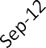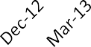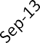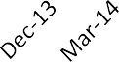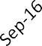

Katherine

DarwinNorth

DarwinRural

DarwinNorthCoastal

Palmerston

DarwinNorthEast

NorthernSuburbs

AliceSprings

InnerDarwin

TennantCreek

$1,200

$1,000

$800

$600

$400

$200

$-

**3 Bedroom House Median Rent**

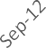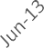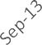

DarwinNorth

DarwinNorthCoastal

DarwinNorthEast

Katherine

Palmerston

AliceSprings

InnerDarwin

$700

$600

$500

$400

$300

$200

$100

$-

**2 Bedroom Unit Median Rent**

Page 26

**RELM**

NortherN territory

report - September Quarter 2017



RENTAL YIELDS

### RENTAL YIELDS

|  |  |  |  |
| --- | --- | --- | --- |
| **MEDIAN OVERALL WEEKLY RENTAL** | | | |
| Location & Dwelling | Price | % Change per Quarter | % Change per Annum |
| **Darwin Overall** | *(Includes Inner Darwin, Northern Suburbs & Palmerston)* | | |
| 3 Bedroom House | 478.0 | -1.2% | -6.5% |
| 2 Bedroom Unit | 366.0 | 0.0% | -5.3% |
| **RENTAL YIELD** | | | |
| **Darwin Overall** | Yield % | % Change per Quarter | % Change per Annum |
| 3 Bedroom House | 5.0% | 0.4% | 0.2% |
| 2 Bedroom Unit | 4.7% | 0.6% | 0.3% |
| **HOUSE RENTAL YIELD - 3 BEDROOM HOUSE** | | | |
| Location & Dwelling | Yield % | % Change per Quarter | % Change per Annum |
| **Darwin Inner** | 4.0% | 0.1% | 0.4% |
| **Darwin North Coastal** | 4.1% | 0.0% | -0.4% |
| **Darwin North East** | 3.4% | 0.1% | -0.4% |
| **Darwin North** | 5.1% | 0.6% | 0.6% |
| **Palmerston** | 4.9% | -0.1% | -0.1% |
| **Katherine** | 7.2% | 0.8% | 0.7% |
| **Alice Springs** | 5.6% | -0.4% | -0.3% |
| **UNIT/TOWNHOUSE RENTAL YIELD - 2 BEDROOM UNIT** | | | |
| Location & Dwelling | Yield % | % Change per Quarter | % Change per Annum |
| **Darwin Inner** | 4.8% | 0.6% | 0.4% |
| **Darwin North Coastal** | 5.9% | 1.2% | 1.5% |
| **Darwin North East** | 3.6% | -1.4% | -0.1% |
| **Darwin North** | 5.6% | 0.2% | 0.9% |
| **Palmerston** | 5.2% | 0.2% | 1.1% |
| **Katherine** | 5.7% | -0.7% | 3.2% |
| **Alice Springs** | 6.0% | -0.8% | -1.2% |

VACANCY RATES

### VACANCY RATES

|  |  |  |  |
| --- | --- | --- | --- |
| **VACANCY RATES - OVERALL DWELLINGS** | | | |
| Location & Dwelling | Rate | Rate - % Change per Quarter | Rate - % Change per Annum |
| **Darwin**  **(including Northern Suburbs)** | 5.9% | -0.6% | -0.8% |
| **Palmerston** | 6.5% | 0.0% | 0.6% |
| **Rural** | 5.9% | -3.4% | -1.7% |
| **Katherine** | 5.1% | -0.2% | 1.7% |
| **Alice Springs** | 3.8% | -0.4% | 0.1% |

|  |  |  |  |
| --- | --- | --- | --- |
| **VACANCY RATES - HOUSES** | | | |
| Location & Dwelling | Rate | Rate - % Change per Quarter | Rate - % Change per Annum |
| **Darwin**  **(including Northern Suburbs)** | 6.9% | 0.0% | 0.2% |
| **Palmerston** | 5.5% | -0.7% | 0.7% |
| **Rural** | 5.7% | -4.3% | -0.7% |
| **Katherine** | 5.2% | -0.6% | 1.8% |
| **Alice Springs** | 1.5% | -1.7% | -0.3% |

|  |  |  |  |
| --- | --- | --- | --- |
| **VACANCY RATES - UNITS & TOWNHOUSES** | | | |
| Location & Dwelling | Rate | Rate - % Change per Quarter | Rate - % Change per Annum |
| **Darwin**  **(including Northern Suburbs)** | 5.7% | -0.7% | -0.9% |
| **Palmerston** | 8.2% | 1.1% | 0.4% |
| **Rural** | 6.8% | 1.3% | -7.0% |
| **Katherine** | 4.9% | 0.8% | -1.0% |
| **Alice Springs** | 5.6% | 0.7% | 0.7% |

NortherN territory

**RELM**

report - September Quarter 2017

Page 29

VACANCY RATES

### VACANCY RATES

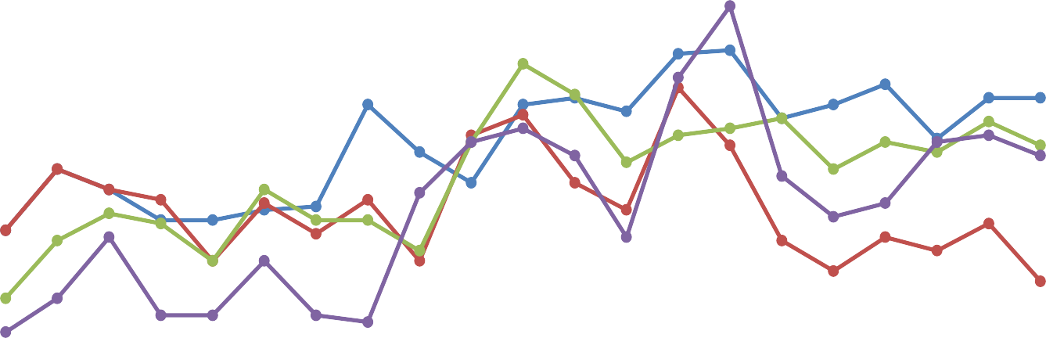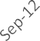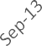

TennantCreek

Rural

Katherine

Palmerston

AliceSprings

Darwin

0.0%

2.0%

4.0%

6.0%

8.0%

10.0%

12.0%

14.0%

**House Rental Vacancy Rates**

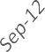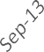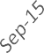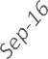

TennantCreek

Rural

Katherine

Palmerston

AliceSprings

Darwin

35.0%

30.0%

25.0%

20.0%

15.0%

10.0%

5.0%

0.0%

**Unit Rental Vacancy Rates**

Page 30

**RELM**

NortherN territory

report - September Quarter 2017

VACANCY RATES

### VACANCY RATES

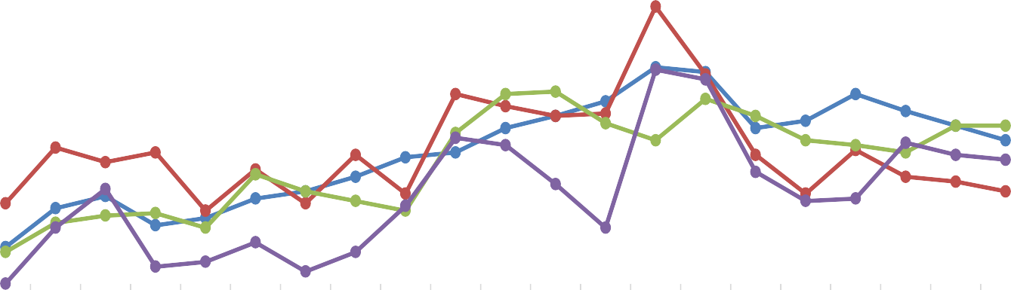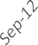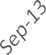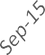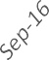

TennantCreek

Rural

Katherine

Palmerston

AliceSprings

Darwin

16.0%

14.0%

12.0%

10.0%

8.0%

6.0%

4.0%

2.0%

0.0%

**Overall Rental Vacancy Rates**



NEW MANDATORY DATA BREACH LAWS*,* ARE YOU READY?

With this year quickly closing out, it’s important to remember that the new Mandatory Data Breach laws will take effect from 7 February in the new year.

There has not previously been in Australia a duty to notify anybody where a party has either disclosed private information in contravention of Australian Privacy Principle under the *Privacy Act 1988* or had private information stolen in a cyber incident.

The *Privacy Act* currently permits the Office of the Australian Information Commissioner (**OAIC**) to impose civil penalties up to $1M plus where there is a serious or repeated interference with privacy.

From February 2017 the *Privacy Amendment (Notifiable Data Breaches) Bill 2016* will impose an obligation on businesses to notify the OAIC where there is an ‘eligible data breach’. An ‘eligible data breach’ (**ED breach**) occurs (with limited exceptions) if:

* + Unauthorised access to, or disclosure of, personal information;
  + Information is lost with a risk of unauthorised access or disclosure; and
  + A reasonable person would conclude that the access or disclosure would be likely to result in serious harm to any of the individuals to whom the information relates.

Accordingly, if personal information is disclosed by a disgruntled employee or obtained in a cyber incident, consideration will have to be given to whether or not a breach of the Act has occurred.

‘Notification’ must be given immediately.

If the business suspects but is not really sure that an ED breach has occurred, it is permitted to carry out a reasonable and expeditious assessment (within 30 days of when suspicion was aroused) to determine if there are reasonable grounds to believe an ED breach has occurred. If it finds none, then the notification provisions are not triggered.

‘Notification’ requires the business to prepare a statement setting out:

* + Identity and contact details of the entity;
  + Description of the eligible data breach;
  + The kind or kinds of information concerned; and
  + Recommendations about steps individuals should take in response to the eligible data breach.

The business must also give a copy to the OAIC and notify contents of the Notice to individuals to whom the information relates.

More broadly, the Australian Securities and Investments Commission (**ASIC**) has taken the view that the *Corporations Act 2001* and general directors’ duties of ‘reasonable care and diligence’ makes cyber resilience a legal duty. That is corporations must guard all information (not just personal information) against unauthorised access, including commercially sensitive information.

CYBER INCIDENT RESPONSE *NINE KEY STEPS*

|  |  |
| --- | --- |
| Identification | * An immediate assessment to identify the nature of the threat, nature of the adversary, and what assets are at risk. * Identify those who need immediate notification, particularly key stakeholders, any cyber risk insurer and engagement of breach response team. |
| Mitigation | * Ascertain what needs to be done immediately to contain the breach and the effects of the incident. * Engage with external assistance as required to manage the breach. * Implement business continuity and/or disaster recovery plan. |
| Investigation | * Consider engaging lawyers to ensure protection of legal privilege over investigation reports. * Interview witnesses (including employees and contractors), engage experts (particularly IT forensics), and establish detail as to what has happened. * Brief witnesses on rights and obligations in regulatory investigations. |



|  |  |
| --- | --- |
| Preservation | * Preserve evidence and retain records/logs in case there is any litigation or regulatory investigation. |
| Evaluation | * Evaluate the impact of the breach - who is affected, what kind of harm (both internally and externally) could result. * Conduct a comparison to the system back up to fully assess the impact of the breach. |
| Notification | * Consider whether notification is required to regulators or law enforcement bodies and to affected individuals or businesses. * Undertake legal vetting of content of any notification. |
| Communication | * Implement communications / PR strategy including with media and with external stakeholders. * Undertake legal vetting of all proposed communications. * Don’t use affected systems for the communication. |
| Remediation | * Consider what assets need restoring, retrieving, recovering or replacing. * Consider and implement remedial steps with external stakeholders or affected individuals e.g. credit monitoring. |
| Prevention | * Document an incident report with key learning outcomes to prevent future similar incidents from occurring and ensure steps are taken in response to the key learnings. * Update breach response plan and cyber security plan to reflect key preventative learnings. |

*This article was written by Tony Morgan, Partner and Nadia D’Souza, Associate.*

TYPICAL LAW FIRM



WE’RE NOT YOUR

Despite what many law firms say, it can be very difficult to differentiate one firm from another. Our rapid rise to become the largest legal partnership in Australia shows that in our case, the differences are real. Let us demonstrate how you can benefit from those differences. Visit our website at hwlebsworth.com.au

Adelaide Brisbane

Canberra Darwin

Hobart Melbourne

Norwest Perth



Sydney

YOUR SUBURB

### A QUARTERLY LOOK AT SALES FIGURES IN YOUR SUBURB

|  |  |  |  |  |  |  |  |
| --- | --- | --- | --- | --- | --- | --- | --- |
| **DARWIN & NORTHERN SUBURBS HOUSES** | | | | | | | |
| Location | No. Sold | % Change Qtr | % Change Annual | Total Sale Amount | Median Price of Sale | % Change Qtr | % Change Annual |
| Alawa | 8 | 14.3% | 60.0% | $4,280,000 | $517,500 | 12.5% | -13.8% |
| Anula | 2 | -83.3% | -75.0% | $1,048,000 | $524,000 | -2.1% | -6.0% |
| Bayview | 1 | -50.0% | -66.7% | $1,345,000 | $1,345,000 | 48.6% | 24.5% |
| Berrimah | 0 |  |  | $- |  |  |  |
| Brinkin | 1 | -50.0% |  | $1,180,000 | $1,180,000 | 23.2% |  |
| Casuarina | 0 |  |  | $- |  |  |  |
| Coconut Grove | 1 | -75.0% | -66.7% | $500,000 | $500,000 | -7.6% | -15.3% |
| Darwin | 0 |  |  | $- |  |  |  |
| Fannie Bay | 5 | 25.0% |  | $5,040,000 | $940,000 | -31.3% |  |
| Jingili | 4 | 0.0% | -20.0% | $2,415,000 | $587,500 | 7.3% | 9.8% |
| Karama | 19 | 58.3% | 216.7% | $8,017,000 | $430,000 | -2.3% | -8.7% |
| Larrakeyah | 0 |  |  | $- |  |  |  |
| Leanyer | 9 | 0.0% | -30.8% | $5,033,725 | $572,000 | 2.1% | 1.2% |
| Ludmilla | 3 | -40.0% | 0.0% | $2,010,000 | $635,000 | 0.8% | -11.8% |
| Lyons | 3 | -57.1% | -50.0% | $2,340,000 | $750,000 | -13.3% | -1.3% |
| Malak | 7 | 75.0% | 75.0% | $2,888,500 | $400,000 | -8.3% | -27.1% |
| Marrara | 1 | -50.0% | -66.7% | $675,000 | $675,000 | -4.9% | -12.3% |
| Millner | 2 | -60.0% | -60.0% | $735,000 | $367,500 | -30.7% | -21.0% |
| Moil | 4 | -50.0% | -42.9% | $2,140,000 | $560,000 | 16.4% | 18.5% |
| Muirhead | 13 | 116.7% | 18.2% | $8,427,500 | $650,000 | -5.5% | -5.1% |
| Nakara | 5 | 150.0% | 25.0% | $2,585,000 | $520,000 | -1.9% | -11.7% |
| Nightcliff | 7 | -12.5% | 133.3% | $5,466,500 | $800,000 | 8.6% | -18.4% |
| Parap | 3 | 0.0% | -40.0% | $2,270,000 | $760,000 | -5.0% | 15.2% |
| Rapid Creek | 4 | 0.0% | 0.0% | $2,886,000 | $743,000 | 0.7% | 13.7% |
| Stuart Park | 4 | 0.0% | 0.0% | $2,455,000 | $585,000 | -25.2% | -20.9% |
| The Gardens | 0 |  |  | $- |  |  |  |
| The Narrows | 1 | 0.0% | 0.0% | $750,000 | $750,000 | 68.5% | 70.5% |
| Tiwi | 5 | 25.0% | 66.7% | $2,993,807 | $470,000 | -9.2% | 6.8% |
| Wagaman | 4 | -20.0% | -20.0% | $1,687,000 | $422,500 | -27.2% | -4.0% |
| Wanguri | 3 | 0.0% | -25.0% | $1,843,000 | $628,000 | -1.2% | 2.5% |
| Winnellie | 0 |  |  | $- |  |  |  |
| Woolner | 0 |  |  | $- |  |  |  |
| Wulagi | 7 | 250.0% | -41.7% | $3,325,000 | $470,000 | -9.6% | -3.6% |

Page 34

**RELM**

NortherN territory

report - September Quarter 2017

YOUR SUBURB

|  |  |  |  |  |  |  |  |
| --- | --- | --- | --- | --- | --- | --- | --- |
| **DARWIN & NORTHERN SUBURBS UNITS & TOWNHOUSES** | | | | | | | |
| Location | No. Sold | % Change Qtr | % Change Annual | Total Sale Amount | Median Price of Sale | % Change Qtr | % Change Annual |
| Alawa | 0 |  |  | $- |  |  |  |
| Anula | 0 |  |  | $- |  |  |  |
| Bayview | 1 | -80.0% | -50.0% | $850,000 | $850,000 | 46.6% | 30.8% |
| Berrimah | 6 | 500.0% | -40.0% | $3,300,000 | $550,000 | 0.0% | 0.0% |
| Brinkin | 0 |  |  | $- |  |  |  |
| Casuarina | 0 |  |  | $- |  |  |  |
| Coconut Grove | 3 | -57.1% | -78.6% | $810,000 | $290,000 | -23.7% | -37.0% |
| Darwin | 37 | 2.8% | 2.8% | $16,115,000 | $470,000 | -4.3% | -17.9% |
| Fannie Bay | 10 | -77.3% | 42.9% | $4,762,500 | $430,000 | -20.4% | -34.8% |
| Jingili | 0 |  |  | $- |  |  |  |
| Karama | 2 | 0.0% | 100.0% | $560,000 | $280,000 | -5.1% | -26.3% |
| Larrakeyah | 30 | 233.3% | 650.0% | $14,400,000 | $465,833 | -4.0% | -21.8% |
| Leanyer | 6 | 200.0% | 200.0% | $1,962,500 | $323,750 | -18.6% | -22.6% |
| Ludmilla | 2 |  | 0.0% | $570,000 | $285,000 |  | -20.1% |
| Lyons | 0 |  |  | $- |  |  |  |
| Malak | 0 |  |  | $- |  |  |  |
| Marrara | 1 | -75.0% |  | $340,000 | $340,000 | -4.0% |  |
| Millner | 1 | -75.0% | -66.7% | $360,000 | $360,000 | 43.4% | -41.5% |
| Moil | 1 |  |  | $237,500 | $237,500 |  |  |
| Muirhead | 3 | 200.0% |  | $1,617,000 | $507,000 | -17.6% |  |
| Nakara | 0 |  |  | $- |  |  |  |
| Nightcliff | 10 | 0.0% | -9.1% | $3,744,000 | $300,000 | -36.2% | -38.1% |
| Parap | 7 | -50.0% | -30.0% | $3,460,000 | $415,000 | -17.4% | -6.7% |
| Rapid Creek | 5 | -16.7% | -50.0% | $1,971,000 | $320,000 | -18.5% | -6.2% |
| Stuart Park | 17 | 54.5% | 41.7% | $7,782,000 | $475,000 | 13.1% | 13.1% |
| The Gardens | 2 | -33.3% |  | $870,000 | $435,000 | -1.1% |  |
| The Narrows | 0 |  |  | $- |  |  |  |
| Tiwi | 3 |  |  | $733,500 | $180,000 |  |  |
| Wagaman | 0 |  |  | $- |  |  |  |
| Wanguri | 0 |  |  | $- |  |  |  |
| Winnellie | 0 |  |  | $- |  |  |  |
| Woolner | 3 | -25.0% | 50.0% | $1,080,000 | $365,000 | -32.4% | -28.4% |
| Wulagi | 1 |  |  | $315,000 | $315,000 |  |  |

NortherN territory

**RELM**

report - September Quarter 2017

Page 35

YOUR SUBURB

|  |  |  |  |  |  |  |  |
| --- | --- | --- | --- | --- | --- | --- | --- |
| **PALMERSTON HOUSES** | | | | | | | |
| Location | No. Sold | % Change Qtr | % Change Annual | Total Sale Amount | Median Price of Sale | % Change Qtr | % Change Annual |
| Bakewell | 6 | 50.0% | 0.0% | $2,355,000 | $390,000 | -14.3% | -14.3% |
| Bellamack | 4 | -20.0% | -20.0% | $2,245,000 | $570,000 | -8.1% | -11.6% |
| Driver | 4 | -60.0% | -33.3% | $1,795,000 | $440,000 | 1.5% | -6.4% |
| Durack | 17 | 54.5% | 183.3% | $8,120,500 | $470,000 | 5.6% | -11.5% |
| Farrar | 3 | 0.0% | 50.0% | $1,585,000 | $540,000 | -2.7% | -10.1% |
| Gray | 4 | -50.0% | 0.0% | $1,429,000 | $374,500 | -5.8% | -9.8% |
| Gunn | 11 | -8.3% | 0.0% | $4,897,500 | $460,000 | -3.9% | -5.2% |
| Johnston | 1 |  | -80.0% | $665,000 | $665,000 |  | 2.3% |
| Marlow Lagoon | 0 |  |  | $- |  |  |  |
| Moulden | 5 | -28.6% | 0.0% | $1,490,000 | $300,000 | -9.1% | -21.1% |
| Palmerston City | 0 |  |  | $- |  |  |  |
| Pinelands | 0 |  |  | $- |  |  |  |
| Rosebery | 10 | 233.3% | 42.9% | $4,856,000 | $485,000 | -14.9% | -3.2% |
| Woodroffe | 11 | 37.5% | 120.0% | $4,464,000 | $415,000 | -5.7% | -11.7% |
| Yarrawonga | 0 |  |  | $- |  |  |  |
| Zuccoli | 5 | -37.5% |  | $2,797,500 | $540,000 | -11.5% |  |

|  |  |  |  |  |  |  |  |
| --- | --- | --- | --- | --- | --- | --- | --- |
| **PALMERSTON UNITS & TOWNHOUSES** | | | | | | | |
| Location | No. Sold | % Change Qtr | % Change Annual | Total Sale Amount | Median Price of Sale | % Change Qtr | % Change Annual |
| Bakewell | 3 | 50.0% | 50.0% | $767,800 | $270,000 | -19.8% | -26.3% |
| Bellamack | 2 | -33.3% | -92.6% | $650,000 | $325,000 | -14.5% | -26.1% |
| Driver | 2 |  | 100.0% | $450,500 | $225,250 |  | -10.3% |
| Durack | 0 |  |  | $- |  |  |  |
| Farrar | 0 |  |  | $- |  |  |  |
| Gray | 3 | 0.0% | 200.0% | $997,000 | $365,000 | 62.2% | -6.4% |
| Gunn | 0 |  |  | $- |  |  |  |
| Johnston | 3 | 50.0% | 0.0% | $1,210,000 | $375,000 | -3.1% | -12.8% |
| Marlow Lagoon | 0 |  |  | $- |  |  |  |
| Moulden | 0 |  |  | $- |  |  |  |
| Palmerston City | 0 |  |  | $- |  |  |  |
| Pinelands | 0 |  |  | $- |  |  |  |
| Rosebery | 6 | 500.0% | 500.0% | $2,130,000 | $347,500 | -9.7% | -24.5% |
| Woodroffe | 0 |  |  | $- |  |  |  |
| Yarrawonga | 0 |  |  | $- |  |  |  |
| Zuccoli | 1 |  | -75.0% | $380,000 | $380,000 |  | -25.3% |

**RELM**

Page 36

NortherN territory

report - September Quarter 2017

YOUR SUBURB

|  |  |  |  |  |  |  |  |
| --- | --- | --- | --- | --- | --- | --- | --- |
| **ALICE SPRINGS HOUSES** | | | | | | | |
| Location | No. Sold | % Change Qtr | % Change Annual | Total Sale Amount | Median Price of Sale | % Change Qtr | % Change Annual |
| Alice Springs | 1 |  |  | $520,000 | $520,000 |  |  |
| Araluen | 10 | -28.6% | 66.7% | $4,914,999 | $496,500 | 2.7% | -17.6% |
| Arumbera | 0 |  |  | $- |  |  |  |
| Braitling | 12 | 20.0% | 50.0% | $5,926,000 | $468,000 | 11.1% | 2.3% |
| Ciccone | 0 |  |  | $- |  |  |  |
| Connellan | 0 |  |  | $- |  |  |  |
| Desert Springs | 6 | 20.0% | 500.0% | $4,421,500 | $663,750 | -3.8% | -25.4% |
| East Side | 9 | 12.5% | 80.0% | $4,660,000 | $495,000 | -5.8% | -3.9% |
| Flynn | 0 |  |  | $- |  |  |  |
| Gillen | 14 | 0.0% | 16.7% | $6,242,500 | $455,500 | 9.8% | 16.6% |
| Hugh | 0 |  |  | $- |  |  |  |
| Ilparpa | 0 |  |  | $- |  |  |  |
| Irlpme | 0 |  |  | $- |  |  |  |
| Larapinta | 6 | -25.0% | -40.0% | $3,062,500 | $428,750 | 2.4% | 61.0% |
| Mount Johns | 1 |  | 0.0% | $675,000 | $675,000 |  | 5.5% |
| Ross | 0 |  |  | $- |  |  |  |
| Sadadeen | 6 | -14.3% | 0.0% | $2,157,000 | $369,750 | -9.8% | -7.2% |
| Stuart | 1 | 0.0% | 0.0% | $535,000 | $535,000 | 11.5% | 17.6% |
| The Gap | 4 | 33.3% | 100.0% | $1,605,000 | $382,500 | 2.0% | -7.8% |
| White Gums | 0 |  |  | $- |  |  |  |

|  |  |  |  |  |  |  |  |
| --- | --- | --- | --- | --- | --- | --- | --- |
| **ALICE SPRINGS UNITS & TOWNHOUSES** | | | | | | | |
| Location | No. Sold | % Change Qtr | % Change Annual | Total Sale Amount | Median Price of Sale | % Change Qtr | % Change Annual |
| Alice Springs | 1 |  | -50.0% | $582,500 | $582,500 |  | 0.0% |
| Araluen | 1 | -80.0% | -50.0% | $592,000 | $592,000 | 31.6% | 70.4% |
| Arumbera | 0 |  |  | $- |  |  |  |
| Braitling | 1 |  | 0.0% | $323,000 | $323,000 |  | 5.9% |
| Ciccone | 0 |  |  | $- |  |  |  |
| Connellan | 0 |  |  | $- |  |  |  |
| Desert Springs | 0 |  |  | $- |  |  |  |
| East Side | 8 | 166.7% | 300.0% | $2,932,500 | $352,500 | 42.4% | 22.6% |
| Flynn | 0 |  |  | $- |  |  |  |
| Gillen | 8 | 100.0% | 60.0% | $2,948,103 | $330,000 | -10.9% | 10.0% |
| Hugh | 0 |  |  | $- |  |  |  |
| Ilparpa | 0 |  |  | $- |  |  |  |
| Irlpme | 0 |  |  | $- |  |  |  |
| Larapinta | 1 | -66.7% |  | $275,000 | $275,000 | 2.6% |  |
| Mount Johns | 7 | 40.0% |  | $1,587,850 | $187,950 | -65.8% |  |
| Ross | 0 |  |  | $- |  |  |  |
| Sadadeen | 2 | 0.0% | 0.0% | $1,610,100 | $805,050 | 278.8% | 159.7% |
| Stuart | 1 | 0.0% |  | $240,000 | $240,000 | -31.4% |  |
| The Gap | 3 | -50.0% | -86.4% | $821,000 | $295,000 | 16.1% | 15.7% |
| White Gums | 0 |  |  | $- |  |  |  |

**National Property Advisory is the leadingindependentproperty valuationandadvisoryserviceprovideracrosstheNorthernT erritory**

AndrewNosed a,F API Mike mcdermott, FAPI Alan ludlow,F API CertifiedPra ctisingV aluer Certified Practising Valuer CertifiedPra ctisingV aluer

**We focus on specialist properties where our team of valuers have extensive experience in providing valuation and consultancyadvice**

Residential Rural

Aged Care / Retirement Hospitality & Tourism Expert Witness

**Contact Us Today** Telephone | 0437 224 947 Email | [info@gpan.com.au](mailto:info@gpan.com.au)

National Property Advisory Suite c306, Level 1, Tower 3 19C KitchenerDrive DDaarrwwiinnNNT 0800



As a member of REINT, youare entitledto take advantage o f the Lexus Corporate Benefits Program There has never been a better lime toowna Lexus. You also getaccess lo Lexus Encore Privileges Progr am.'

Corporate Benefitsinclude: Encore Privileges Program includes:

3 year/ 60,000 kmcomplimentaryschedule · 4 year/100,000 km warranty (whichvee「 occusrlirst)

servci ing. · Service Loan Cars or compiml Reduced dealerpre-deilveryfee drop-offduring servicing

entarypick-up/

Co rporatediscounts on selected vehicles · Lexus Drivecareproviding24hrs roadside assitsance

To find out more about this program, and what other benefitsyou may qualify for, pleasecontact Rob Longuet on (08) 8946 0000or 0 412 898 875. \.

、

REINT

. c0 咋 心＂ c比 如 知、＂小叩 res3 ye改'”以泣 立 叩 f心n扣 ii,,t, 如,al，叩如 心 n. I竹心m” “ 心,s l,,sLl0.1 肛 印心 rs心 啦 cles叩 l e邓 咕心 咖 c1e叩 ＇，呻 心 汕 foc

［，也欢＆喊b ＆ 心 1，归yd 心中 过 戏 心 心 叩 J..。山氏l tou 立心如 ib d' ,d 叨心1口 n LMVDOO1

ANNUAL CHARTS

### CHARTING

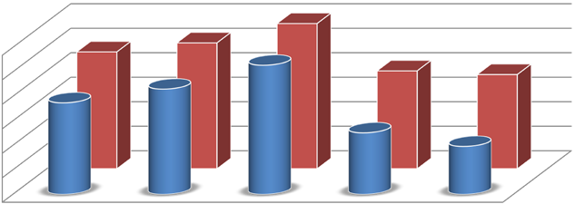

Units Houses

2016/2017

2015/2016

2014/2015

2013/2014

2012/2013

$-

Units

$200,000,000

Houses

$1,200,000,000

$1,000,000,000

$800,000,000

$600,000,000

$400,000,000

**Northern Territory Total Property Sales**

Financial Year Reporting

**RELM**

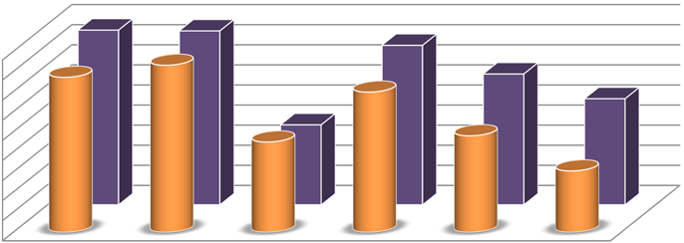

Units Houses

2012 2013 2014 2015 2016 2017

Units

200

0

Houses

1,800

1,600

1,400

1,200

1,000

800

600

400

**Northern Territory Recorded Sales**

Calendar Year Reporting

Page 40 NortherN territory

report - September Quarter 2017

ANNUAL CHARTS

|  |  |  |  |  |  |  |
| --- | --- | --- | --- | --- | --- | --- |
| 1,800 |  | | | | | |
| 1,600 |  |  |  |  |  |  |
| 1,400 |  |  |  |  |  |  |
| 1,200 |  |  |  |  |  |  |
| 1,000 |  |  |  |  |  |  |
| 800 |  |  |  |  |  |  |
| 600 |  |  |  |  |  |  |
| 400 |  |  |  |  |  |  |
| 200 |  |  |  |  |  |  |
| 0 | 2011/2012 | 2012/2013 | 2013/2014 | 2014/2015 | 2015/2016 | 2016/2017 |

Financial Year Reporting

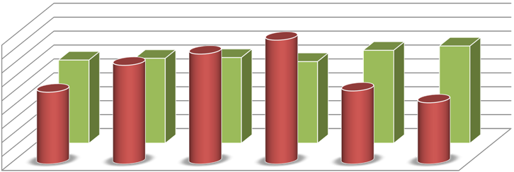

**Darwin Overall Recorded Sales**

Units Houses

CHANGES TO RELM

### NEW REPORTING AREAS

To better report on and express the values of rental data, including rental yields, the REINT and its partners Global Property Analytics have devised a more robust reporting regime and have renamed the zones previously reported as Nightcliff, Marrara and Sanderson, to better reflect the nature of the areas.

From the December 2014 issue of RELM we instituted the following definitions and will be using these from here-on. The REINT feels these better describe the areas covered rather than identifying through a mix of a single suburb and electoral zones.

* Inner Darwin remained as is and covers the suburbs indicated in this list;
* Nightcliff is now reported as Darwin North Coastal and covers the suburbs indicated in this list;
* Marrara is now reported as Darwin North East and covers the suburbs indicated in this list;
* Sanderson is now reported as Darwin North and covers the suburbs indicated in this list; and
* Palmerston, Rural areas, Katherine, Tennant Creek and Alice Springs remain unchanged.

**INNER DARWIN**

* Bayview
* Cullen Bay
* Darwin (inc. DC & MC)
* East Point
* Eaton
* Fannie Bay
* Larrakeyah
* Ludmilla
* Parap
* RAAF Base Darwin
* Stuart Park
* The Gardens
* The Narrows
* Tipperary Waters
* Woolner

**DARWIN NORTH COASTAL**

* Alawa
* Brinkin
* Casuarina
* Coconut Grove
* Jingili
* Lyons
* Milner
* Moil
* Muirhead
* Nakara
* Nightcliff
* Rapid Creek
* Tiwi
* Wagaman
* Wanguri

**DARWIN NORTH EAST**

* + Berrimah
  + Marrara
  + Winnellie

**DARWIN EAST**

* + Coonwarra
  + Darwin Airport

**DARWIN NORTH**

* Anula
* Bagot
* Buffalo Creek

Charles Darwin University Holmes

•

•

•

•

•

•

•

•

•

•

Karama Leanyer Lee Point Malak Northlakes Sanderson

Woodleigh Gardens Wulagi



Page 42

Cover built for you



Created solely for real estate agents and offers a tailor made solution for your professional indemnity insurance.

###### Easy to arrange



Competitive terms

Simple cover options

Fully endorsed by REI

|  |  |  |  |
| --- | --- | --- | --- |
|  | |  |  |
|  |  |  |  |
|  |  |  |  |
|  |  |  |

Flexible payment options



Tailored protection to meet your

specific needs

REI members receive discounted premiums

Excellent customer service & claims support

**Give the team at Realcover a call today for an obligation free quote on 1800 990 312 or email realcover@jlta.com.au**

Any advice in this document is general advice and does not take into account your objectives, financial situation or needs. You should consider the relevant Policy Wording and your objectives, financial situation or needs before acting on this advice. Please visit [www.realcover.com.au](http://www.realcover.com.au/) or contact Realcover on 1800 990 312 for copy of the Policy Wording.

0874/108/2016

**The NorTherN TerriTory real esTaTe local MarkeT reporT**

**RELM**

**is produced iN collaberaTioN wiTh**

Global properTy aNalyTics

The Real Estate Institute of Northern Territory Inc.

3/6 Lindsay Street, Darwin, NT, 0800 GPO Box 3869, Darwin, NT, 0801

Telephone: +618 8981 8905

Fax: +618 8981 3683

Email: [reception@reint.com.au](mailto:reception@reint.com.au) Website: [WWW.REINT.COM.AU](http://WWW.REINT.COM.AU/)

The market rental information and all data published in this report is derived from data sources believed to be reliable however the REINT does not warrant or guarantee this in any manner. While the REINT has full confidence in the data contained within this publication, no warranty, guarantee or holding out, either expressed or implied is given and persons or companies who pursue financial investment or otherwise act on the basis of this data do so at their own risk. The sales information for the Northern Territory is supplied by Global Property Analytics and is derived from sources including the Lands Titles Office of the Northern Territory. This data is, to the best knowledge of the REINT, true and correct. The REINT acknowledges the assistance of Global Property Analytics and REINT Members for their contributions.

Copyright © 2017 REINT